Hunting through Log Data with Excel

***SUPPLEMENT***

GIAC GCIH Gold Certification

Author: Greg Lalla, greg.lalla@mail.com

Advisor: Christopher Walker, CISSP, GWEB, GCED, CCISO, GCUX, GCWN, GSEC

Accepted: March 25, 2017

Abstract

Gathering and analyzing data during an incident can be a long and tedious process. The vast amounts of data involved in even a single system intrusion can be overwhelming. Larger and well-funded incident response teams typically have a Security Information and Event Management (SIEM) product at their disposal to help the responder sift through this data to find artifacts relevant to the intrusion. This paper will demonstrate to the reader how to use Microsoft Excel and some of its more advanced features during an intrusion if a SIEM or similar product is not available to the incident responder.

# Introduction

## Linux Logs

The formatting of logs produced by many applications and services in Linux make importing the data into Excel challenging. The manual massaging of the data is not difficult but must be done in several stages using a variety of tools. Many of the tools originated on the UNIX operating system, but the ones used in this document have all been ported over to Windows. These tools are from the GNU utilities run under the Open Source tools package CYGWIN.

### System Logs

Linux produces several plain text system logs that may have value to the incident response analyst and which all have the same log format. Below we will look specifically at the Auth.log file which contains user authentication information, but we can use the same techniques against the Daemon.log file, Boot.log file, Mail.log file and others. See http://www.thegeekstuff.com/2011/08/linux-var-log-files/ for a listing of system logs that may appear on a Linux host.

To import the Auth.log into Excel, you need to correct the dates as well as the points of delineation of the fields in the log. Here is an example line from an Auth.log file obtained from the honeynet project (Arcas, 2011):

*Feb 6 13:02:48 victoria login[2032]: ROOT LOGIN on 'tty1'*

The problems of the date field at the start of each line is that it spells out the abbreviation for the month; does not have a “0” in front of single digit days of the month (1-9), and does not contain the year. To solve the first two problems, you can run a simple script against the file that changes the month to a number and inserts a “0” in front of days 1 thru 9. Here is the syntax to fix the date of the single entry shown above using the SED tool:

*sed ‘s/Feb /02\/0/’*

The result would look like this:

*02/06 13:02:48 victoria login[2032]: ROOT LOGIN on 'tty1'*

To cover all the months in a year, you can use a file on the GitHub page called months.sed, which contains the regular expressions for each month (https://github.com/gregory-lalla/GCIH_Gold/Misc/SED_Month_Replacement_Filter/months.sed). To invoke the script run:

*sed -i -f months.sed auth.log*

To fix the year and the delineation, we need to turn to an “advanced” text editor, such as Notepad++, UltraEdit, 010 Editor, etc. In the instructions below, we will be using Notepad++.

After running the SED script, open the modified auth.log file in Notepad++. You’ll see that the date has changed to the new month and day layout (Figure 1).

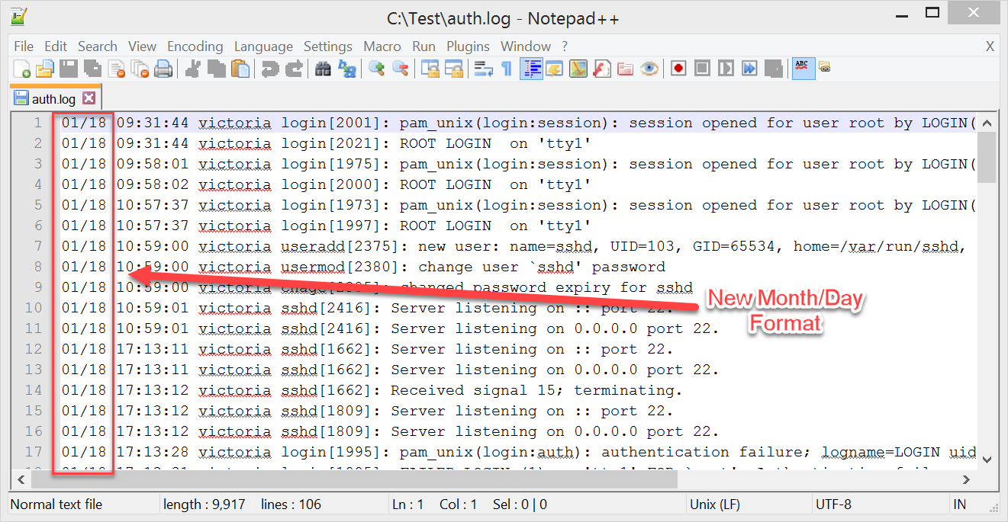

Figure . Change month name to month number. (Arcas, 2011)

To completely fix the date, you need to add the year. Notepad++ has a “vertical” or “column” select feature which will help with adding the year. The first step is to place the cursor immediately after the “day” on the first line of the log (Figure 2).

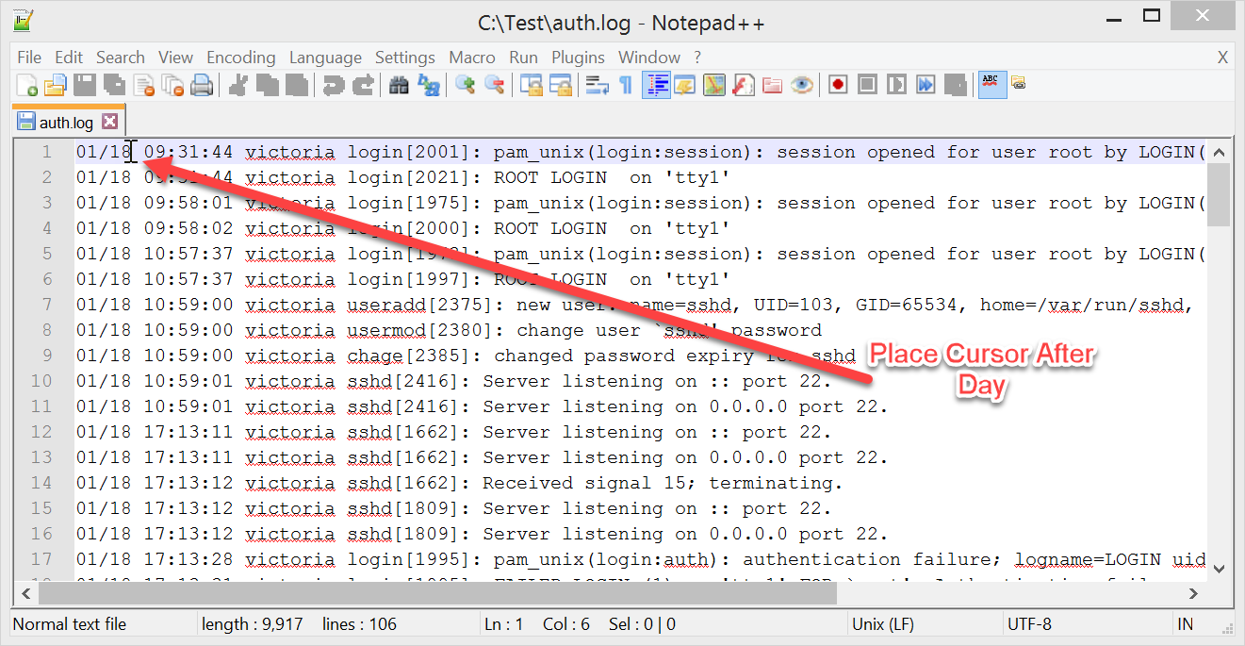

Figure . Add year to date. (Arcas, 2011)

Scroll to the end of the log file and then hold down the SHIFT and ALT keyboard keys while clicking immediately after the “day” on the last line (Figure 3 – Step 1). This action will produce a visible line vertically down the page which will act as the cursor for all lines (Figure 3 – Step 2).

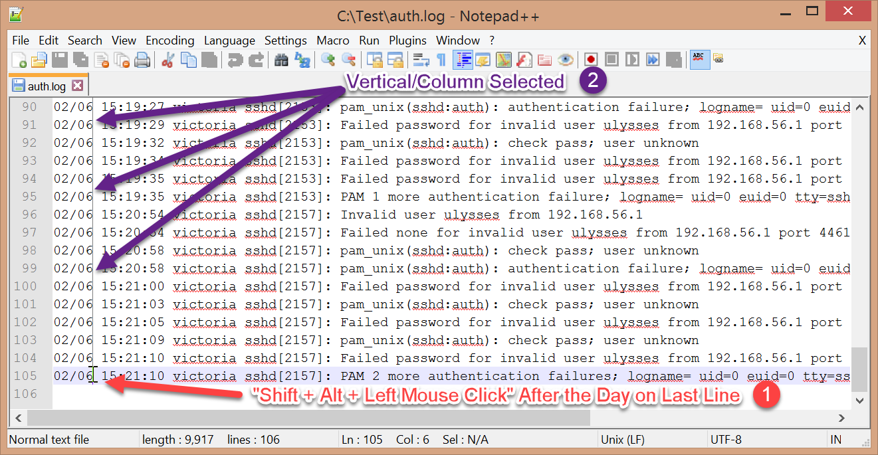

Figure . Vertical select. (Arcas, 2011)

When you type, the characters will show up on every line. This will allow us to enter the year in every line by just typing it once (Figure 4).

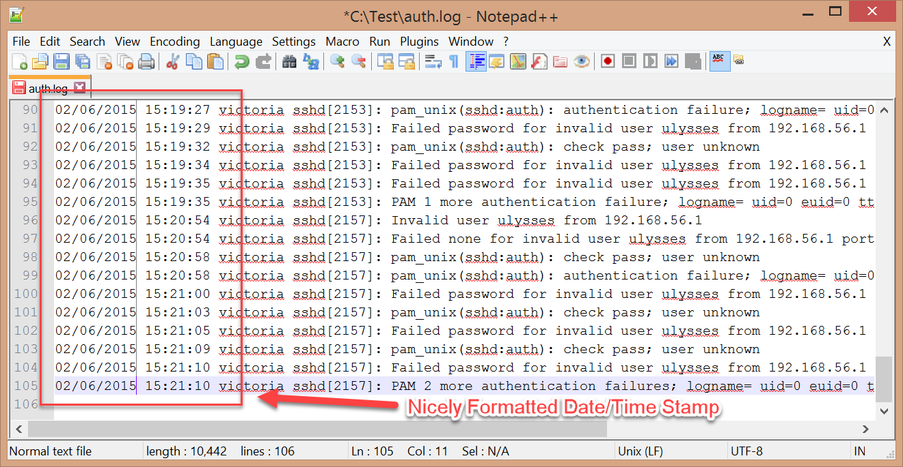

Figure . Date/Time properly formatted. (Arcas, 2011)

With the timestamp corrected, it is time to insert the delimiters. You’ll accomplish this delineation by using the ‘Search/Replace’ feature. When you import the log file into Excel, it will have four columns: Date/Time, Computer, Description, and Details. To separate the columns Date/Time, Computer, and Description, we will search for the pattern: ‘space character’, computer name, ‘space character’ and replace it with the pattern: delimiter, computer name, delimiter. In our example, the search term (without the quotes) will be “ victoria ”, and the replace term will be “#victoria#”. The pound character was chosen as the delimiter because it did not appear in the log file and can therefore reliably be used to separate the fields. To separate the Description and Details columns, we will replace “]: ” (there is a space after the colon) with “]#”. The final result looks like Figure 5.

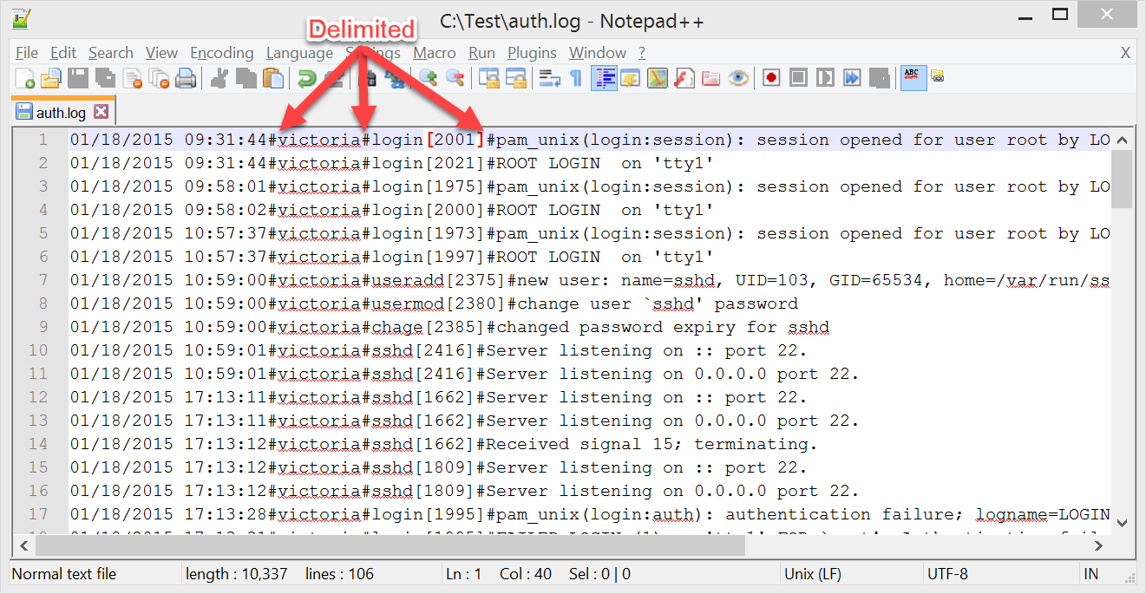

Figure . Add delimiters. (Arcas, 2011)

The auth.log file can now be manually imported into an Excel document, choosing ‘#” as the delimiter. The Excel import will look like Figure 6.

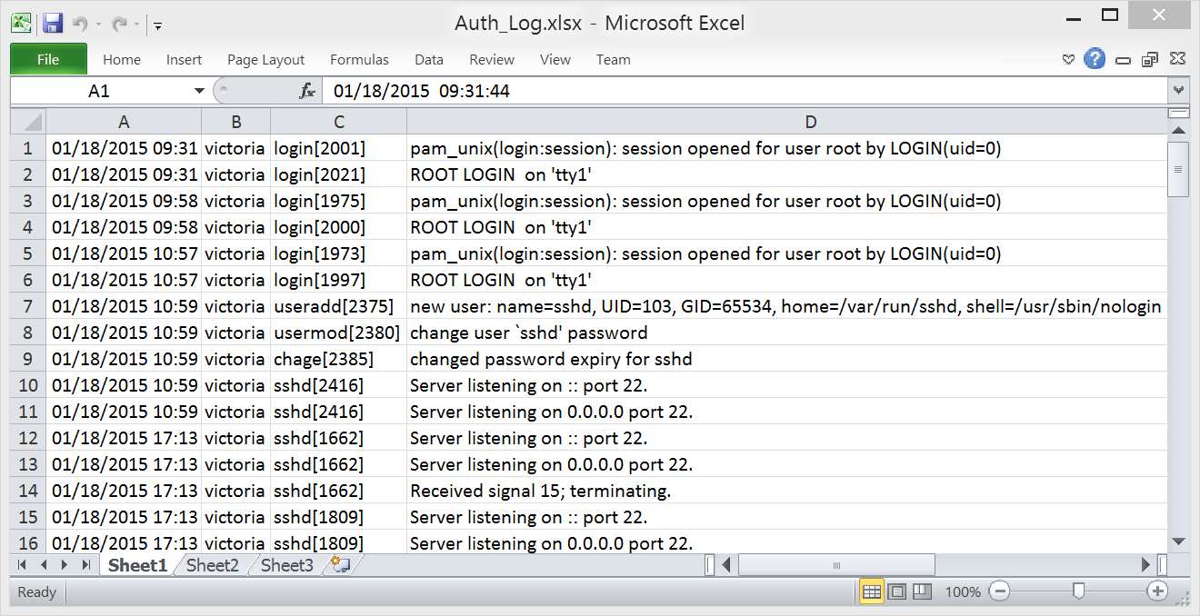

Figure . Import into Excel. (Arcas, 2011)

As before, create the column headers and apply the standard formatting. Afterward, the spreadsheet should look similar to Figure 7.

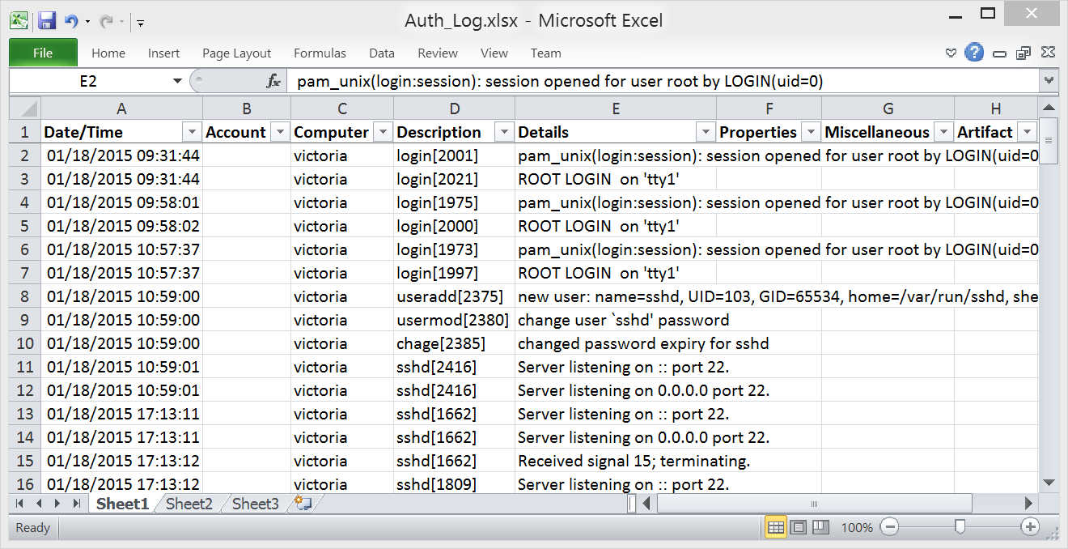

Figure . Standard heads and formatting applied. (Arcas, 2011)

The final step is to add to each cell under the Artifact header the value ‘Auth.log’. The final result will look like Figure 8.

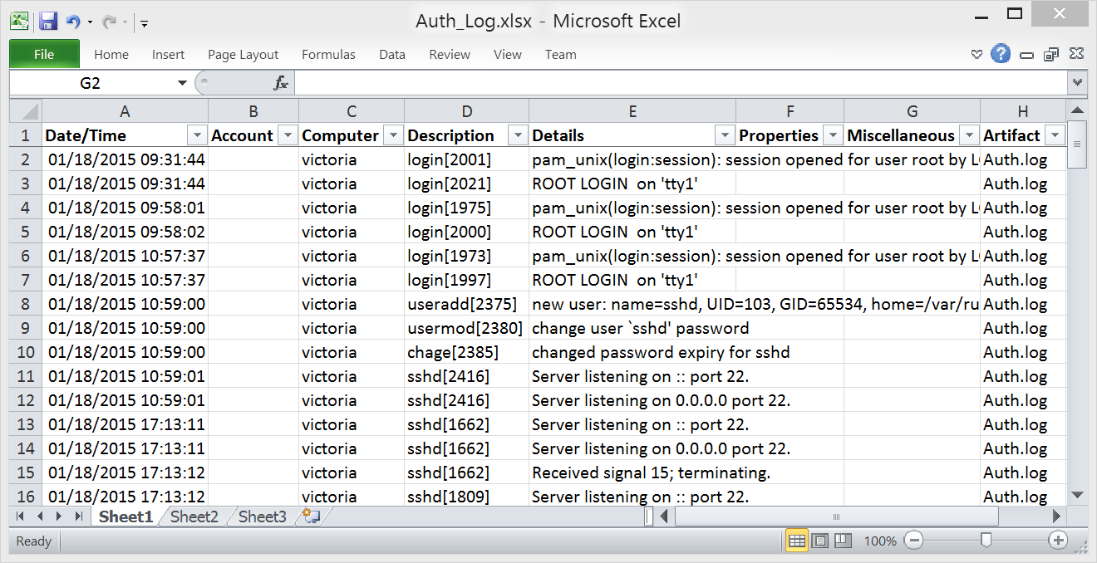

Figure . Final result. (Arcas, 2011)

### Syslog

The syslog daemon handles messages from the entire system to include many of the system logs mentioned above. Depending on the configuration of the logging in the syslog.conf configuration file, the bulk of the message usually are sent to the ‘syslog’ (often named ‘messages’) log file. The syslog file is similar in format to other Linux system logs needs the date fixed and delimiters set in the correct locations.

Since the syslog file is similar in format to the Linux auth.log described above, we will only highlight the differences in this section. Entries from the syslog file look similar to these three lines (Arcas, 2011):

*Jan 18 11:00:40 victoria shutdown[2672]: shutting down for system halt*

*Jan 18 11:00:40 victoria init: Switching to runlevel: 0*

*Jan 18 17:14:35 victoria kernel: [ 9.862291] udevd version 125 started*

Notice that we have the same issue with the dates, which you can fix with the SED tool and month.sed script used previously. However, the delineation of the lines is going to be slightly different. Some entries have the same “]: ” characters, but other lines just have a colon. Delimiting on just the colon will not work because it is a commonly used character in logs and appears in locations where it is not advantages to delimit into a column. To solve this problem, we will search using the term “ victoria ” (without the quotes) and replace it with the term “: victoria: ” to have a common delimiter. However, we only want the first three “: ” to be used as delimiters (Figure 9).

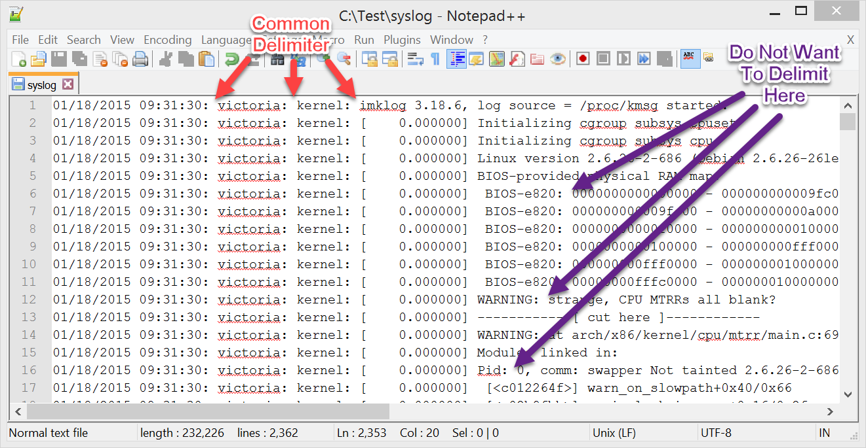

Figure . Delimiters. (Arcas, 2011)

We can delimit on just the first three “: ” by using the following SED command (John1024, 2014):

*sed -i -E 's/: /\^/g4; s/: /~/g; s/\^/: /g' syslog*

The SED command replaces “: ” with “^” for the fourth colon on a line and all colons after it to the end of the line. It then finds the remaining “: ” characters (the first three we wanted to keep) and replaces those with “~”. Finally, the “: ” characters we replaced with the “^” are switched back to “: ”.

The tilde and carrot characters were chosen as delimiters because they did not appear in the log file and could therefore reliably be used to separate the fields (Figure 10).

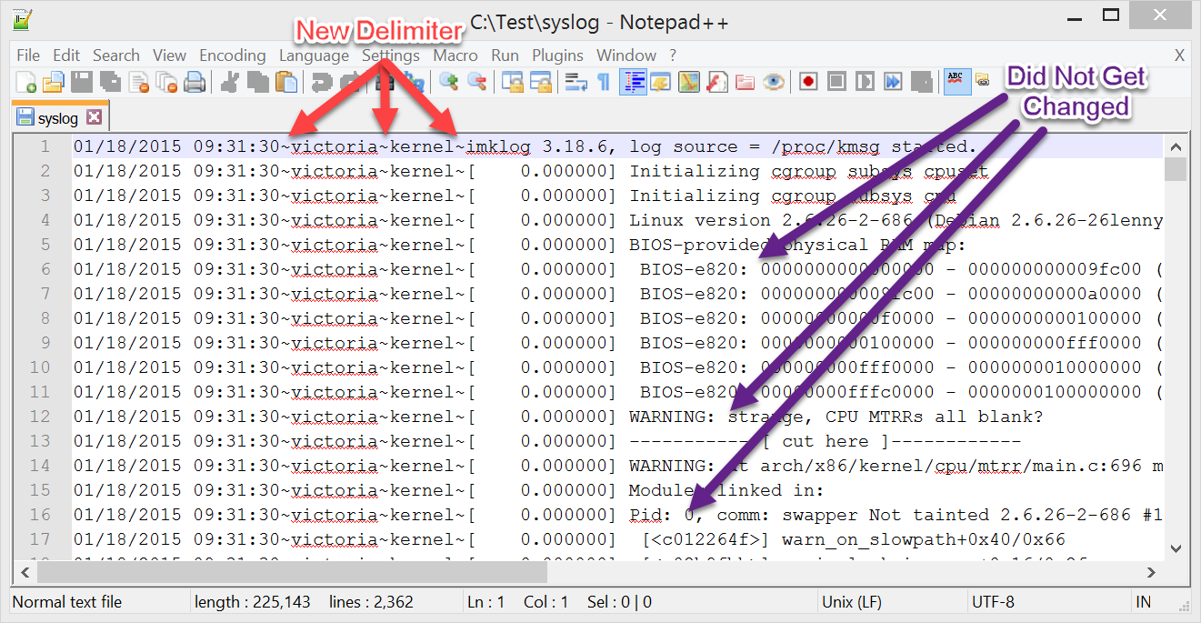

Figure . Changing the delimiters. (Arcas, 2011)

After the updated syslog file has been imported into Excel and all the formatting applied, the resultant spreadsheet should look like Figure 11.

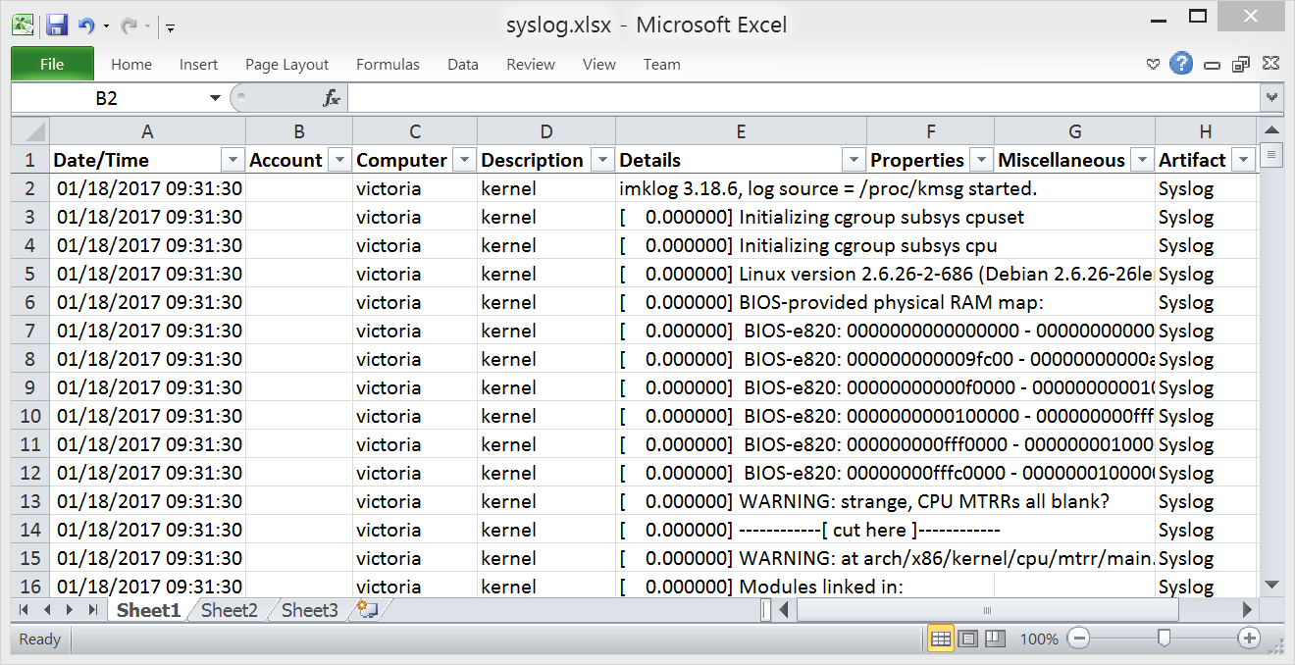

Figure . Final result. (Arcas, 2011)

### Cron Logs

The Cron logs record the activity of the cron jobs (scheduled tasks) run on the system. Often, an intruder will use cron jobs to run their tools at specific times during the day. Again, these logs are similar to other Linux system logs, and we’ll use CYGWIN to manipulate them to the desired output.

First we’ll fix the dates with the same ‘month.sed’ file we have used previous:

*sed -i -f months.sed auth.log*

This time, the year will be provided directly from the SED command line:

*sed -i -E 's/ /\/2004-/; s/: /\^/g4; s/: /~/g; s/\^/: /g; s/\[[^][]*\]//; s/~\(/#/g; s/~/###/g; s/\) /#/g; s/ \(/#/g; s/\)//g; s/ /\^/g3; s/ /#/g; s/\^/ /g; s/2004-/2004 /' cron.log*

The SED command looks confusing, but it is simply a sequence of search and replace statements performed one after another until the data looks the way we want it to look. For this log file, the data is manipulated into six columns when imported into Excel (Figure 12).

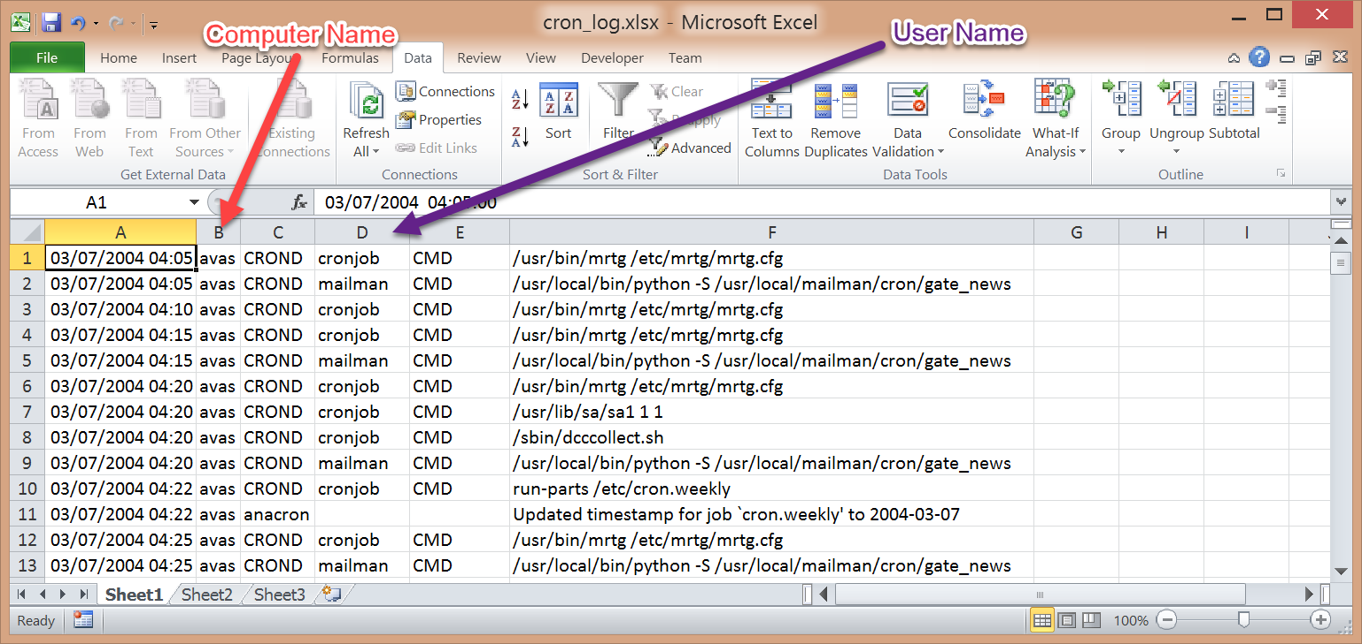

Figure . Data imported into Excel. (Gerhards, 2004)

After you add the standard formatting and standard columns, the final look should be similar to Figure 13.

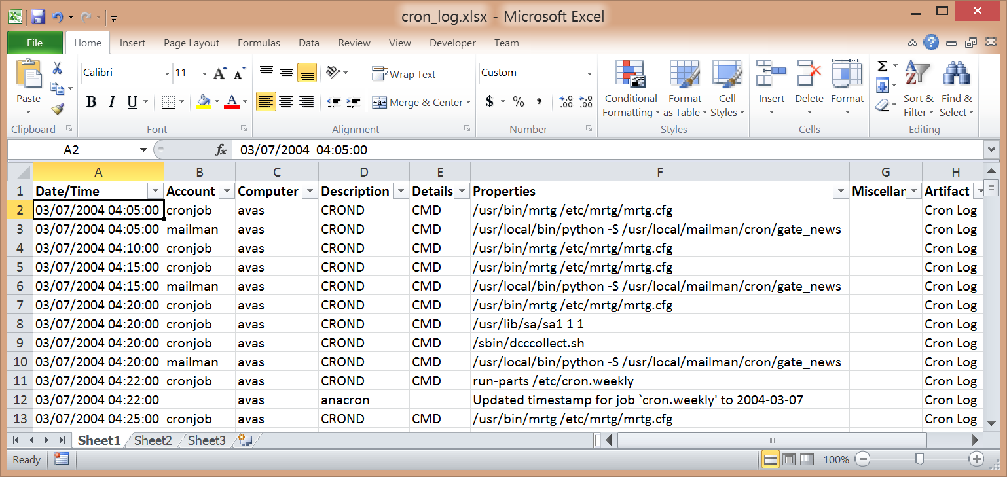

Figure . Final result. (Gerhards, 2004)

## Web Server Logs

### IIS Web Logs

The native format of the IIS Web log allows for easy importing of data into Excel. However, the scattering of headers throughout a log file presents the only real issue. You can filter on the Date/Time column for entries that are not in the Date/Time format to remove the extra headings.

First, import the web log file into Excel using the “space” character as the delimiter. Once done, remove the first three rows of the spreadsheet. Then you need to delete cell “A1”, which should contain the string: ‘#Fields:’. Last, the remaining header fields in the first row need to be shifted to the left (Figure 14).

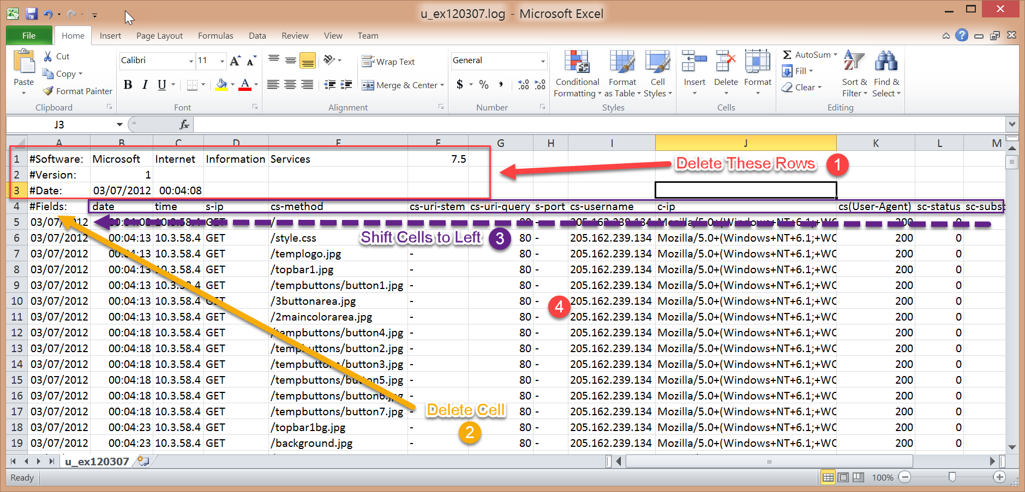

Figure . Delete first three rows and shift header fields to the left. (Lee, 2014, digital case files)

After applying the standard formatting, the log file should look similar to Figure 15.

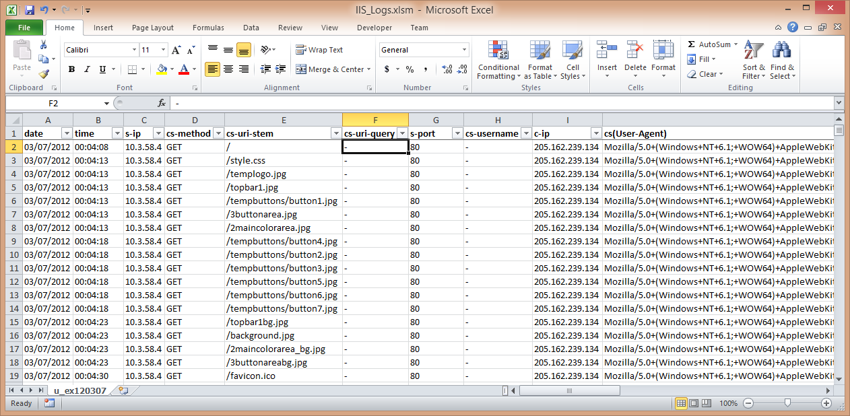

Figure . Standard formatting applied. (Lee, 2014, digital case files)

There is still an issue with other header sections remaining in the document. You can filter on non-dates in the Date column to find the headers (Figure 16).

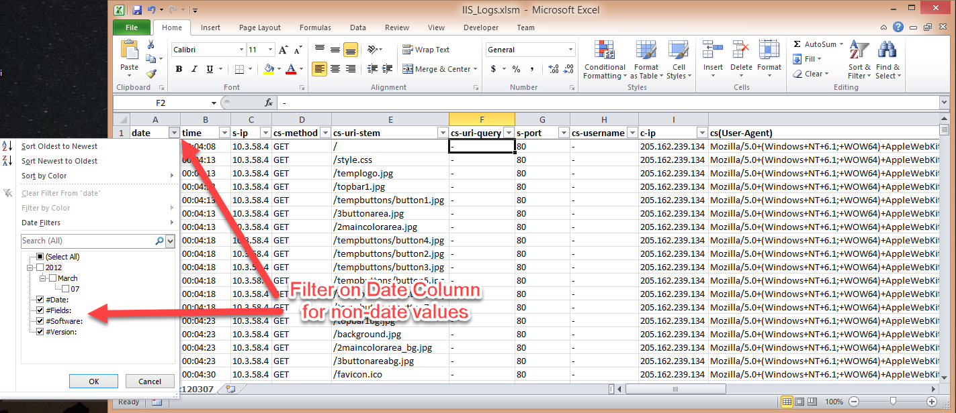

Figure . Finding IIS header rows. (Lee, 2014, digital case files)

You will see all the headers remaining in the file when you apply the filter to the Date column. You should select the displayed rows and delete them (Figure 17).

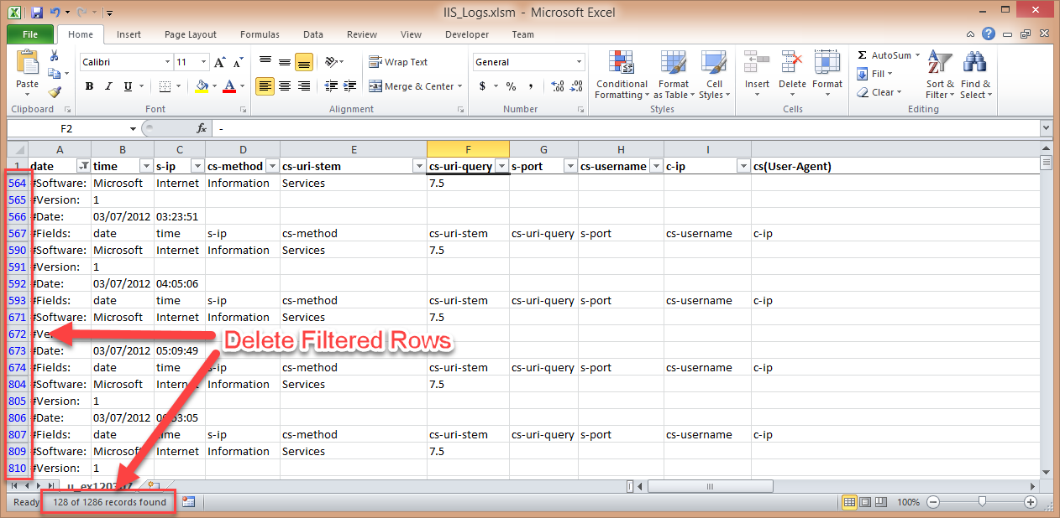

Figure . Deleting IIS header rows. (Lee, 2014, digital case files)

One other action needs take place before we can start to move the columns around and that is to combine the ‘date’ column with the ‘time’ column into one ‘Date/Time’ column. As we’ve done before, a simple function can be used to combine the columns into the proper format (Figure 18):

*=A2 + B2*

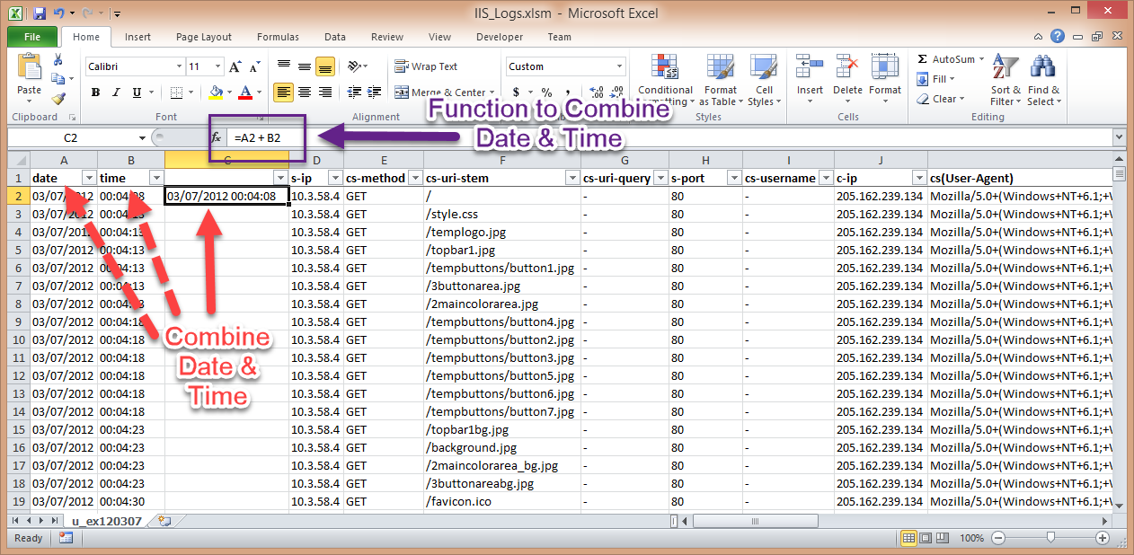

Figure . Combine Date and Time columns. (Lee, 2014, digital case files)

After the Date/Time column is formatted correctly, delete the following columns: cs-uri-query, cs-username, sc-substatus, sc-win32-status, time-taken. To conserve columns, combine the s-ip and s-port columns into one and the cs-method and cs-uri-stem columns into another (Figure 19).

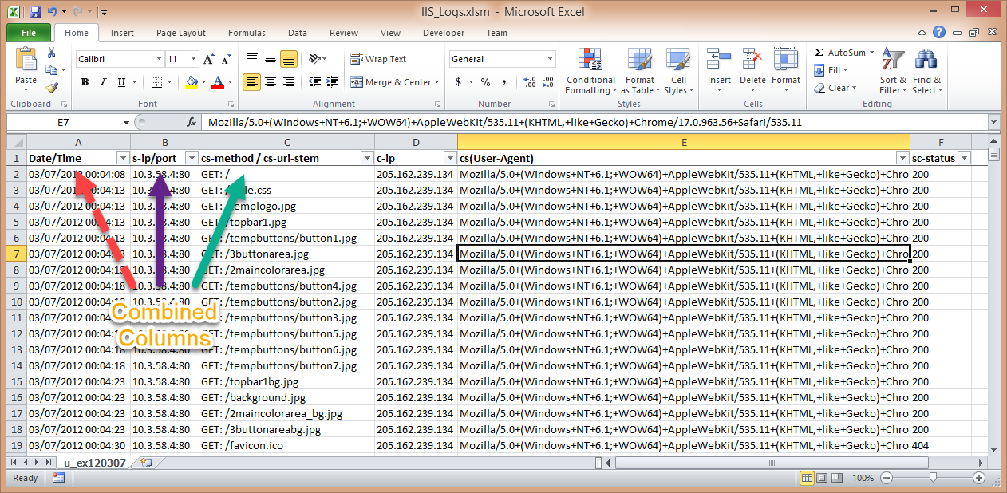

Figure . Combine additional columns. (Lee, 2014, digital case files)

Prepend the string ‘status code: ’ to the “Miscellaneous” column and ‘Client IP Address: ’ to the “Details” column. Then complete the remaining steps of adding standard columns and headers to get a result similar to Figure 20.

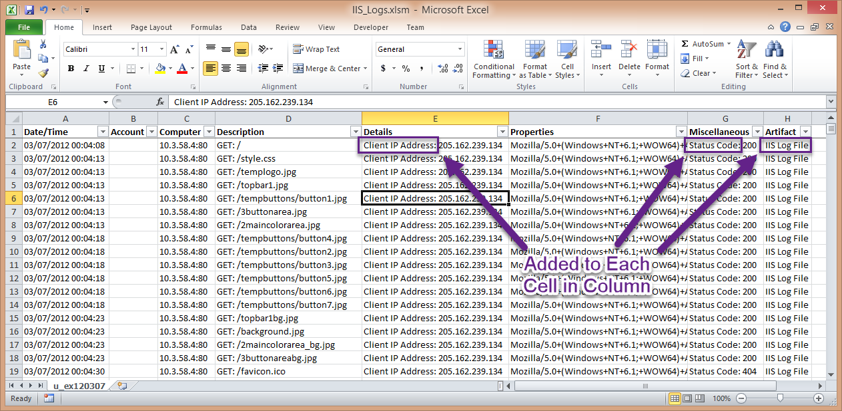

Figure . Standard headers and formatting applied. (Lee, 2014, digital case files)

### IIS FTP Logs

The IIS FTP logs follow the same format as the IIS Web logs, so we will not go over the same information. Figure 21 is an image of an FTP log first imported into Excel.

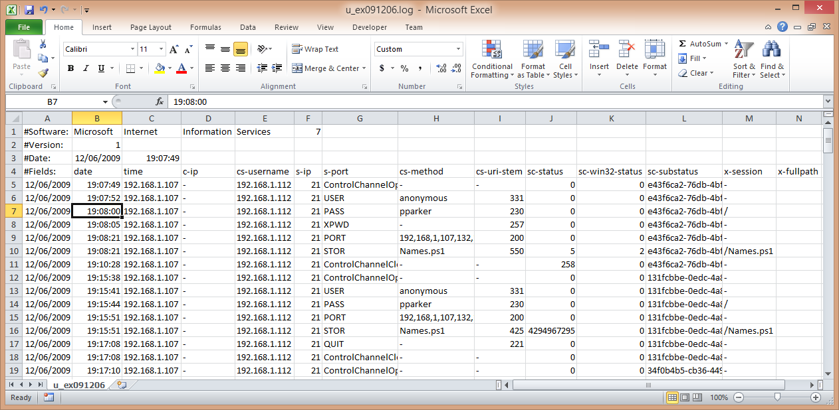

Figure . Data imported into Excel. (Lee, 2014, digital case files)

After performing the same manipulations that were done on IIS Web logs, you should see a result similar to Figure 22.

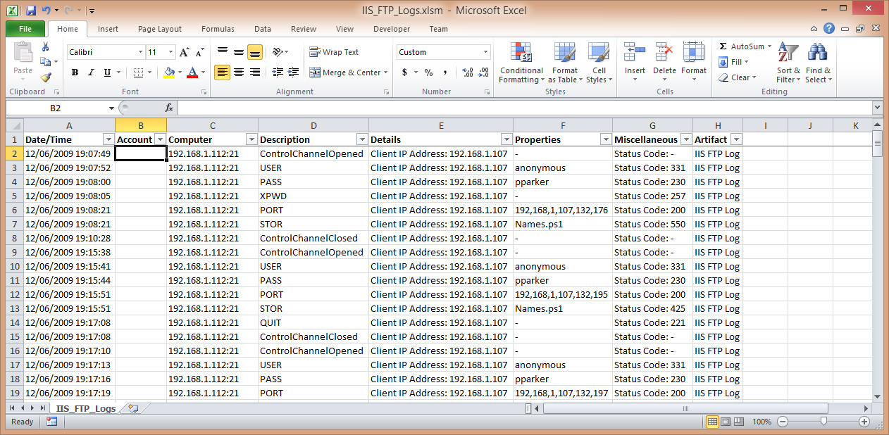

Figure . Final result. (Lee, 2014, digital case files)

### Apache Access Logs

Another log you may find on a Linux server is the Apache www-access.log file which records connections made from a client to the web services of the system. Web servers are often exploited and could provide the adversary with an initial stepping stone into a network. What gets logged can vary based on the configuration of the web server. Regardless of the settings, the logs should import into Excel with the ‘#’ character as the delimiter.

First we’ll clean up log entries with the following SED command:

*sed -i -E 's/ /#/g; s/:/ /; s/\[//; s/\]//; s/"//g' access.log*

Once complete, delete all columns to the right of I, and then delete columns H, C, and B (Figure 23).

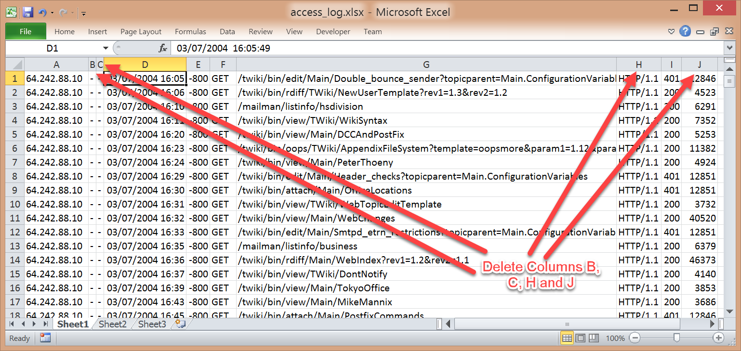

Figure . Delete columns. (Marty, 2010)

A couple of minor adjustments still need to be made. First, the HTTP Code column will need to have the string ‘HTTP code: ’ prepended to it for clarity. Second, you must take into account the time zone offset of the Date/Time (Figure 24).

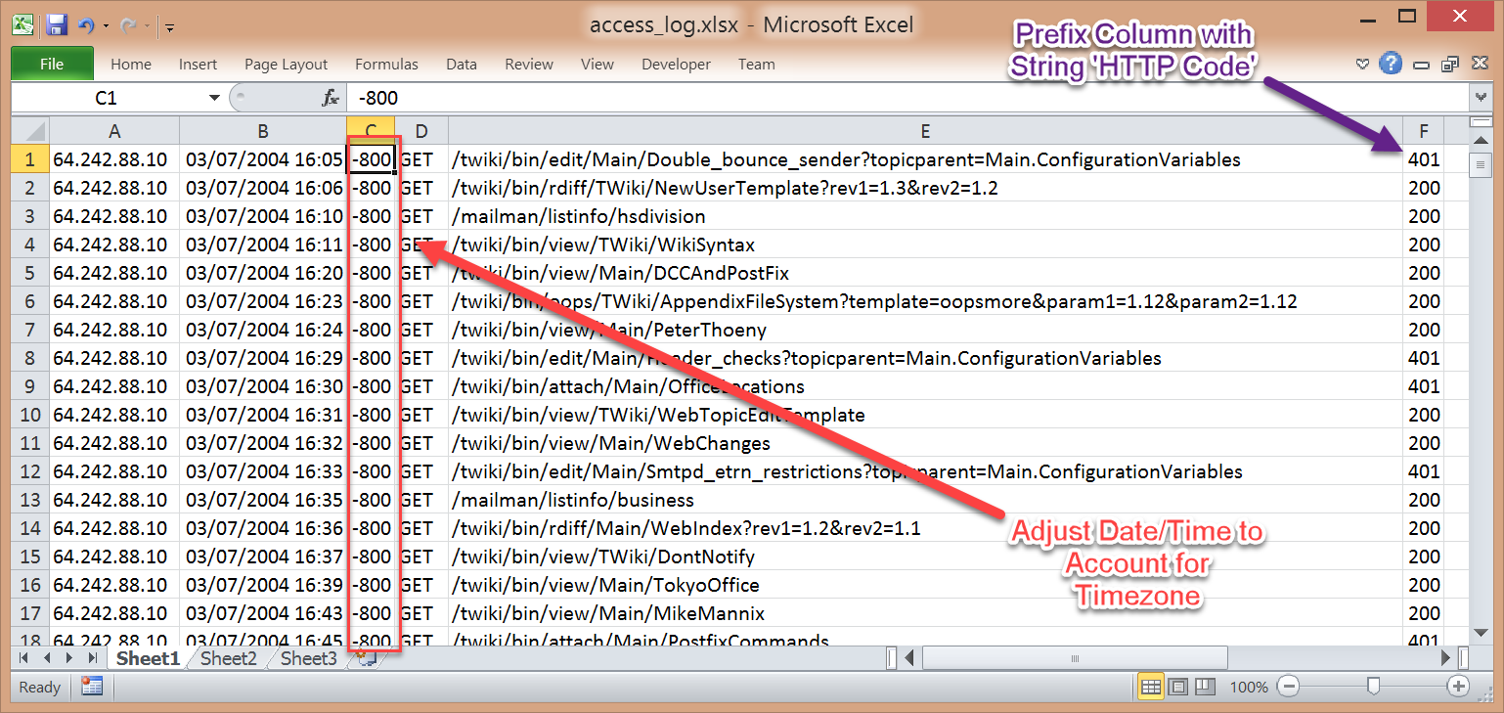

Figure . Time zone information in data. (Marty, 2010)

Since you need to adjust all times to UTC, a function will be used to change the time by the proper offset (in this case, 8 hours). To make time adjustment, you’ll add 8/24th of a day (or 8 hours) to the Date/Time column with this statement (Figure 25):

*=B1 + 8/24*

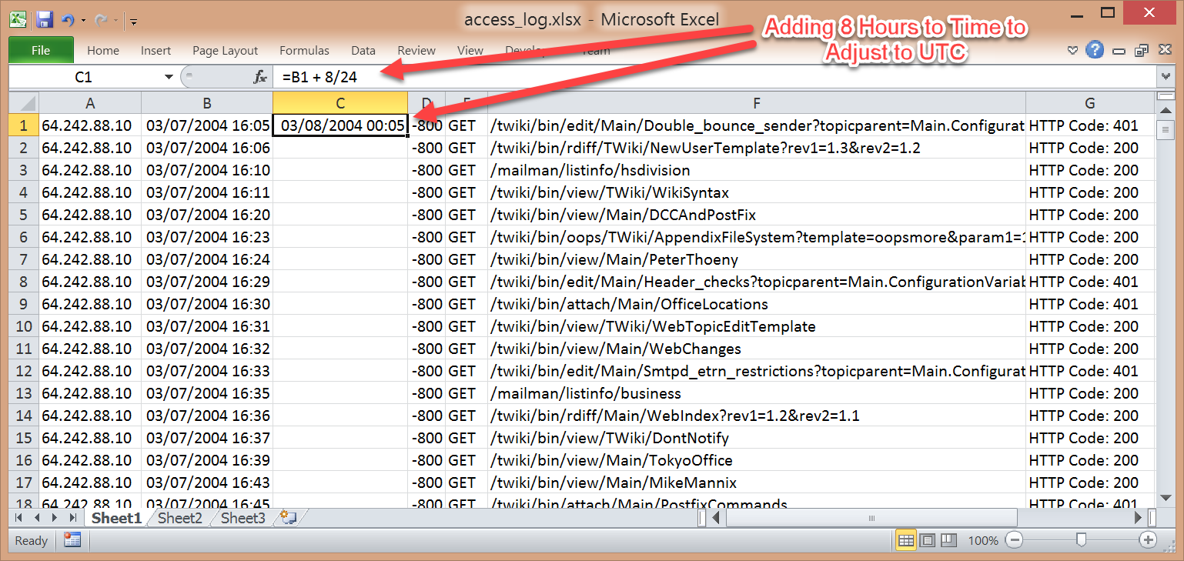

Figure . Change Date/Time to UTC time zone. (Marty, 2010)

Apply the standard columns, headers, and formats, and the result should look similar to Figure 26.

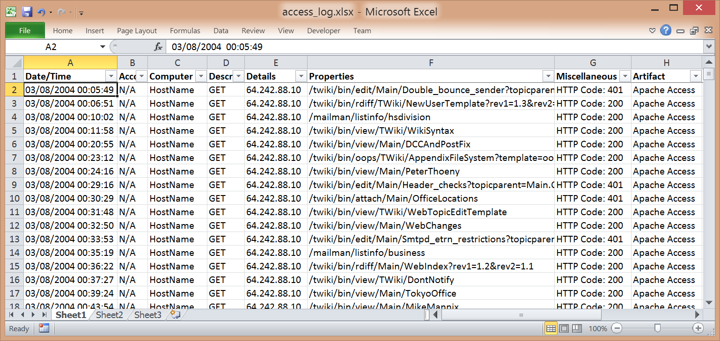

Figure . Final result. (Marty, 2010)

### Apache Error Logs

The Apache Error logs contain web server error and resource alerts. The formatting of this log is similarly to the Linux system logs discussed previously. The log should have the dates and delimiters corrected, so each field is in its proper column. The first step is to remove the “day of the week” words from the beginning of each line by running the following command:

*cat error.log | cut -d' ' -f2- | sed -E '/^$/d; ' > error.log*

Next, we’ll use the months.sed file from earlier to change the month name into the corresponding month number:

*sed -i -f months.sed error.log*

Finally, to fix the rest of the Date/Time field and place the delimiters in the right locations, execute the following command (Jimmij, 2015):

*sed –i –E 's/\(.*\)] /\1#/; s/\] \[/~/g; s/: /~/' error.log*

When importing into Excel, the ‘#’ character will be used to delimit the data. The import will create two columns which you will further delineate by using the tilde character (Figure 27).

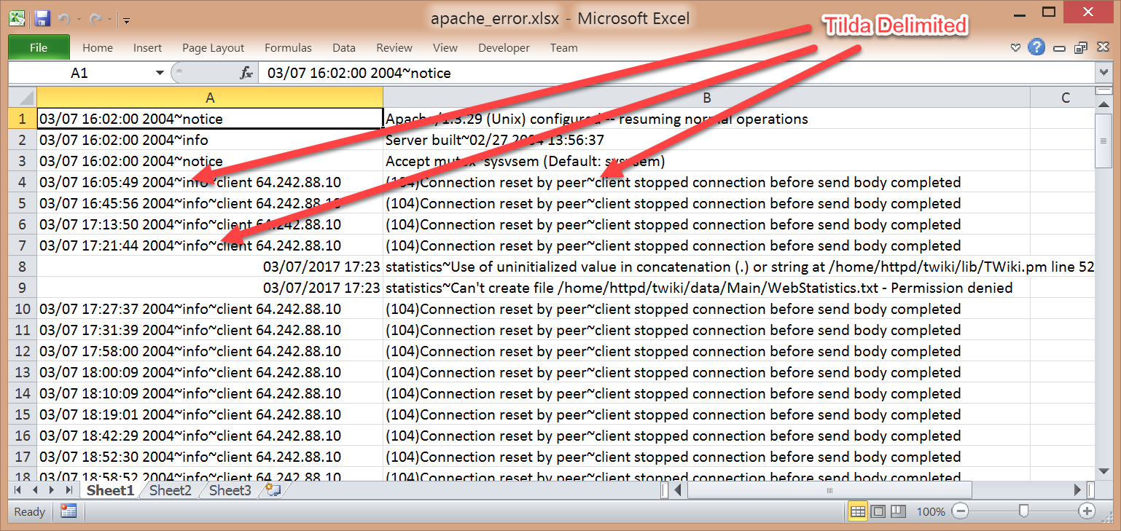

Figure . Delimited columns. (Marty, 2010)

The first column has up to two delimiters. You will insert a column between Columns A and B to prevent overwriting the current contents of Column B (Figure 28 – Step 1). You then highlight the first column and choose the ‘Text to Columns’ button on the ‘Data’ ribbon (Figure 28 – Step 2).

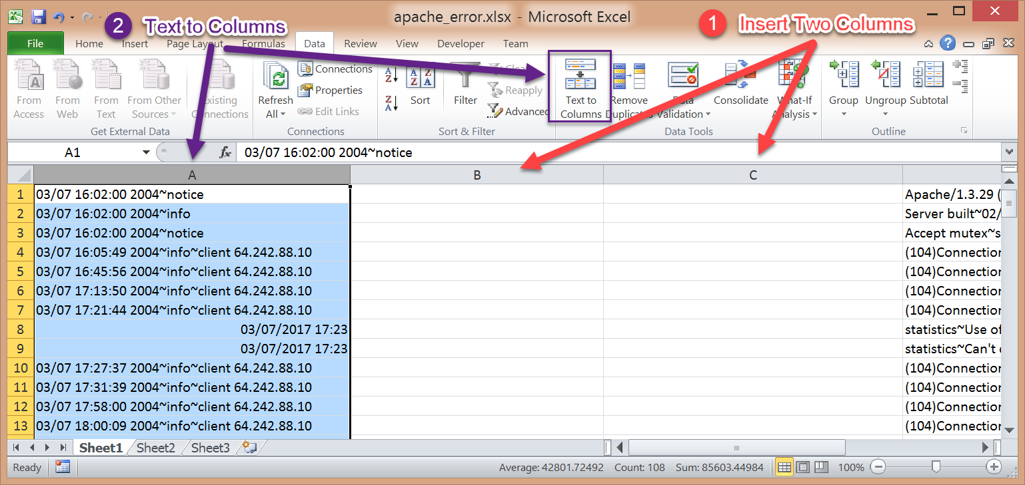

Figure . Text to column conversion. (Marty, 2010)

Once Column A has been separated into the appropriate columns, the new Column D, can also be separated using the same technique. The result of all that work should look like Figure 29.

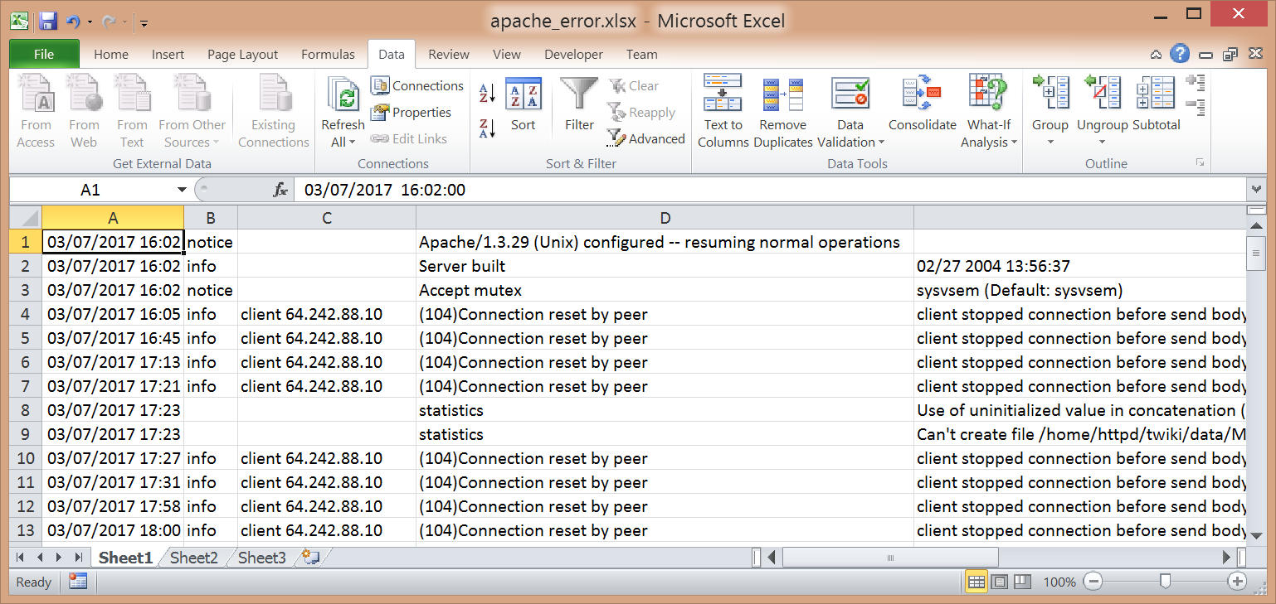

Figure . Data separated into columns. (Marty, 2010)

Apply the rest of the standard columns, headers, formats and the result should look similar to Figure 30.

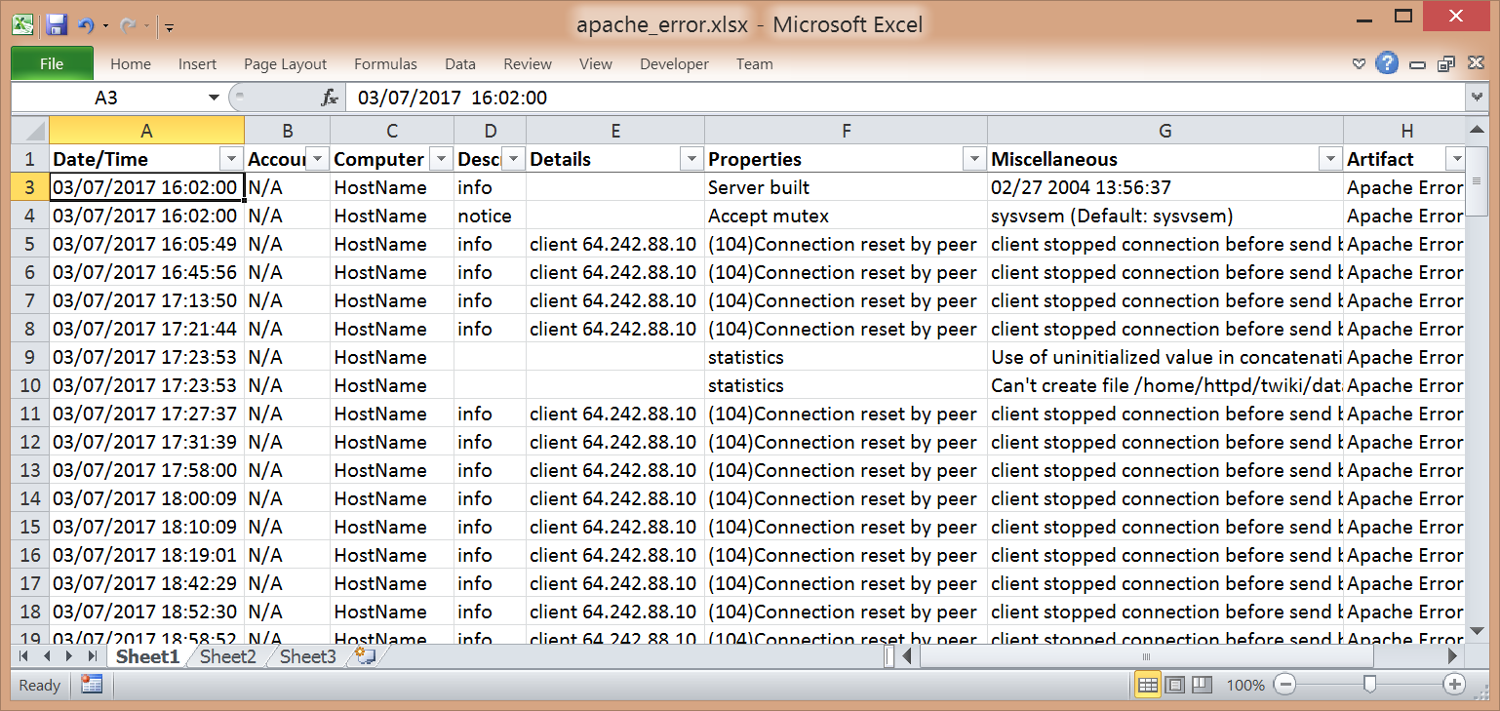

Figure . Final result. (Marty, 2010)

## Network Traffic

Scrutinizing network traffic when combined with other types of artifacts may also be beneficial to your investigation by identifying communications associated with the event and adding those IP addresses to your keywords for further examination.

### IPTables

IPTables and most other firewalls will produce logs that can be exported and examined. IPTables is run on Unix/Linux systems and has logs similar in format to the Linux system logs discussed earlier in this paper. The first step in the process of getting the data imported into Excel is to fix the date. First, we change the Month name to its number using the months.sed script:

*sed -i -f months.sed iptables.log*

Next, you will fix the year, and insert the ‘#’ character as the delimiter with the following command:

*sed -i -E 's/ /\/2015~/; s/ /#/; s/: /#/; s/ IN=/#IN=/; s/MAC=/ MAC=/; s/ DF / /; s/~/ /' iptables.log*

When importing into Excel, the ‘#’ character will be used to delimit the data. The import will produce four columns, with the last one needing to be subdivided further (Figure 31).

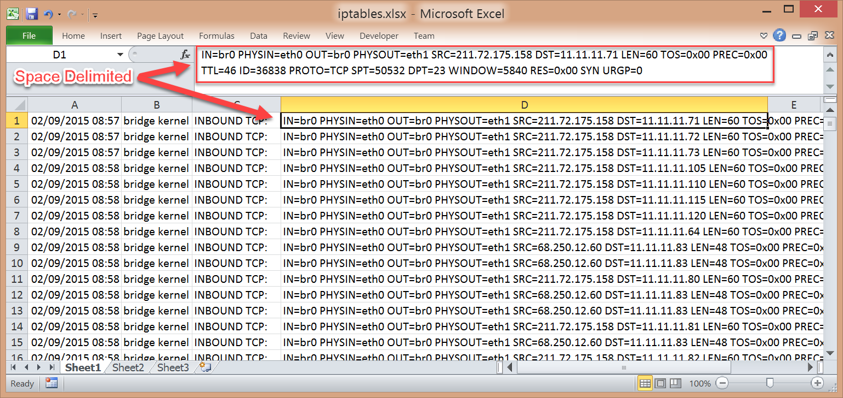

Figure . Data imported into Excel. (Chuvakin, 2004)

Highlight column D and select the ‘Text to Columns’ button on the ‘Data’ ribbon. Select the ‘Space’ delimiter and verify that ‘Treating consecutive delimiters as one’ is not checked (Figure 32).

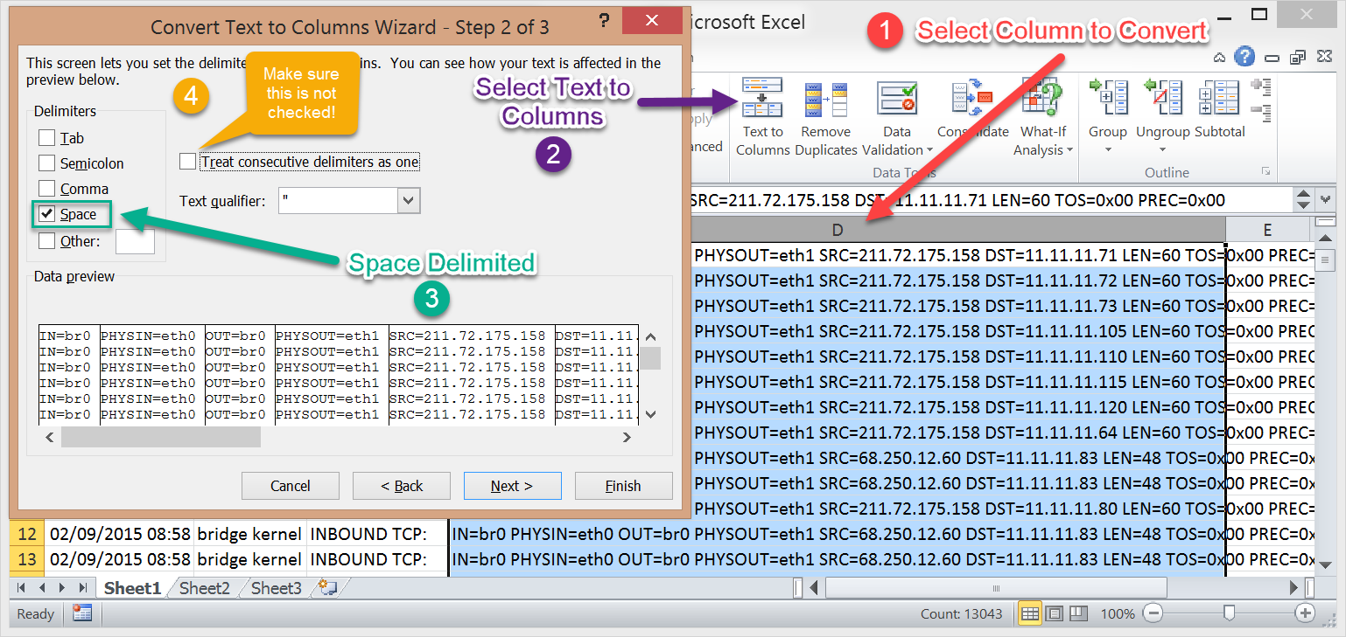

Figure . Text to columns wizard. (Chuvakin, 2004)

After the data is separated into columns, delete all the columns in the spreadsheet except A, C, H, I, P, Q, T, U, V, W. Combine the columns that contain the source IP address and source port together; the destination IP address and destination port together; and the TCP Flags together (Figure 33).

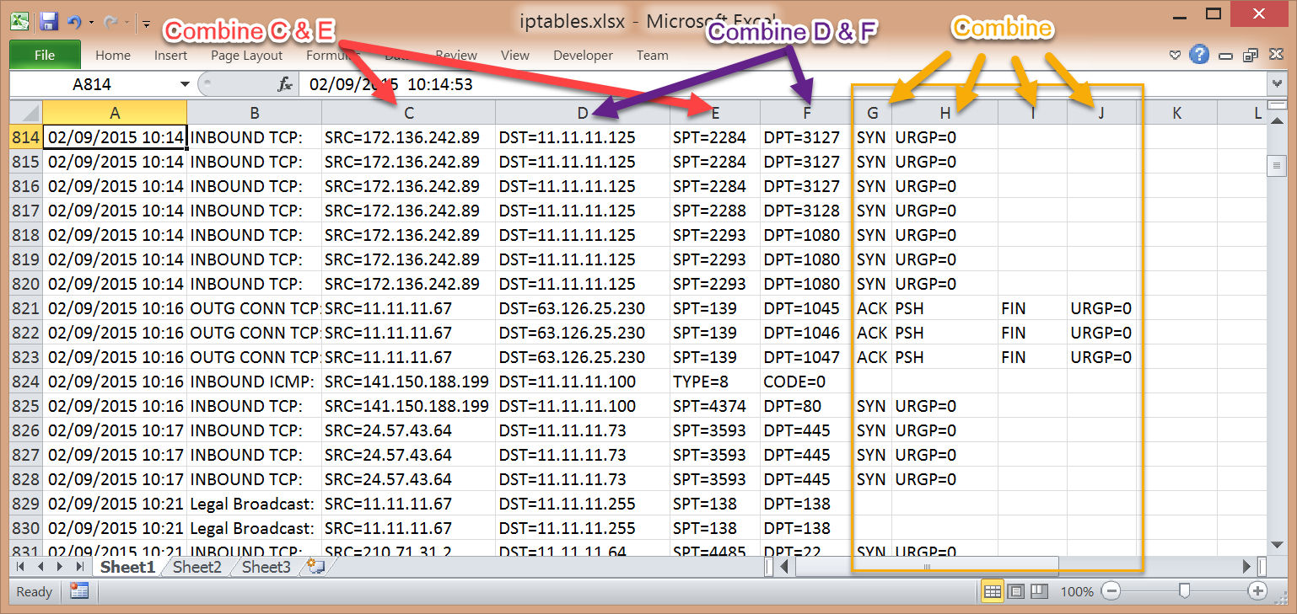

Figure . Combine columns. (Chuvakin, 2004)

When the columns have been combined, in this case using the pipe character (“|”) to separate the fields, the spreadsheet should look similar to Figure 34.

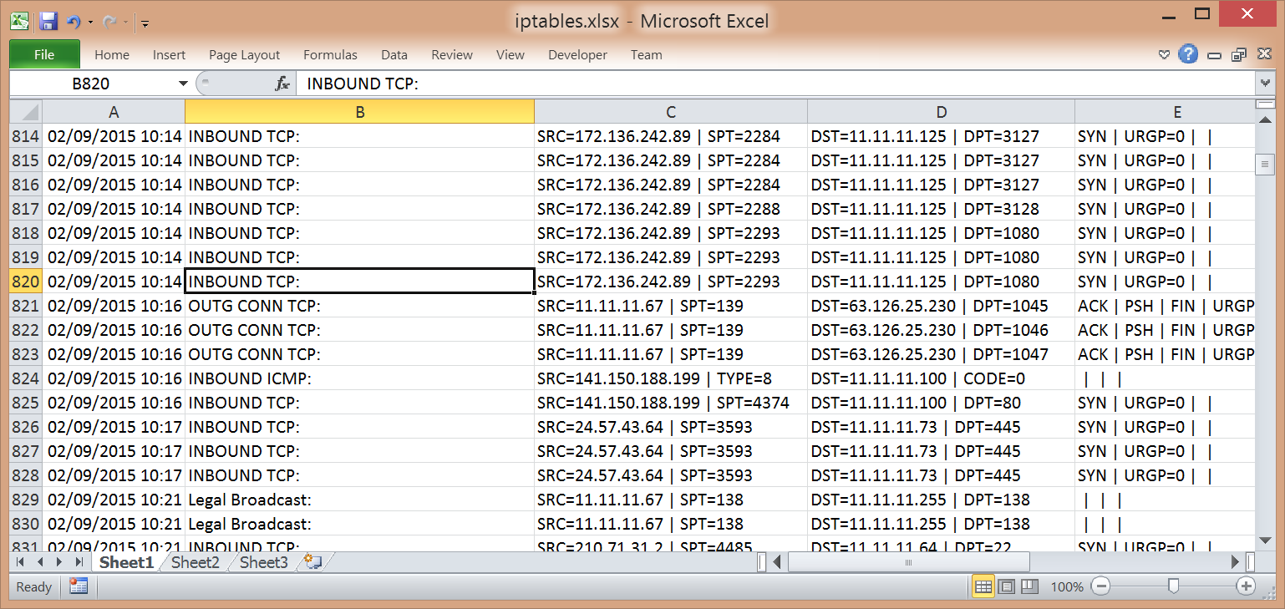

Figure . Pipe character as separator. (Chuvakin, 2004)

Apply the rest of the standard columns, headers, formats and the result should look like Figure 35.

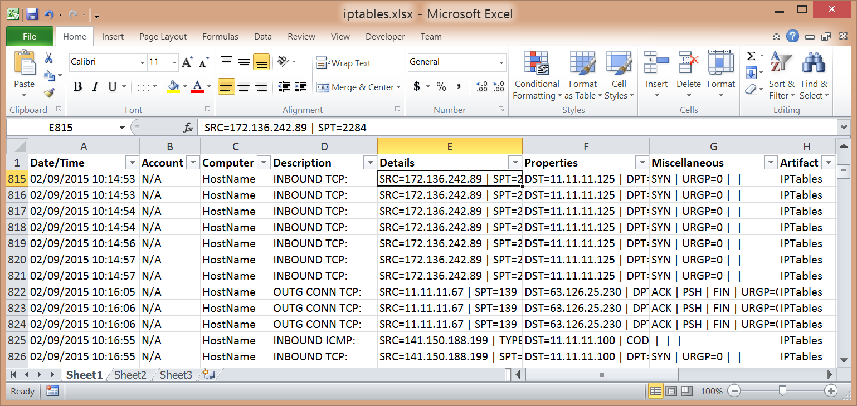

Figure . Final result. (Chuvakin, 2004)

### Packet Captures

Packet Captures can be included as well into the analysis of the incident. First, open the pcap file in Wireshark (Figure 36).

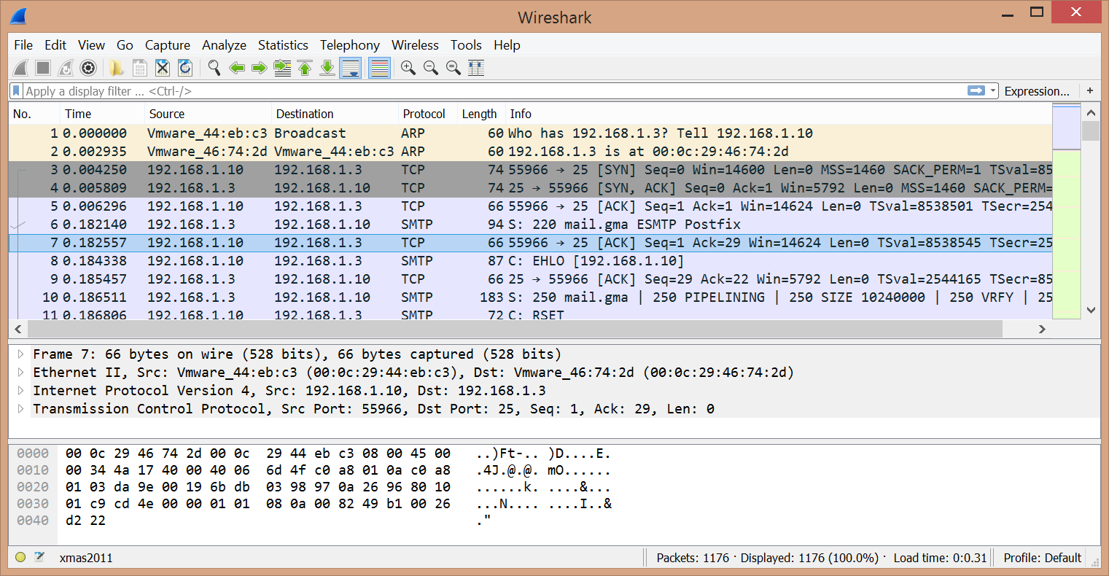

Figure . Pcap file opened in Wireshark. (Skoudis, 2011)

For the packet information to get formatted correctly when exported, the default display columns in Wireshark need to be changed. On the toolbar, click ‘Edit’ and then ‘Preferences…’. In the Preferences pop-up window, under ‘Appearance’, select ‘Columns’. Change the layout of the columns to match what is shown in Figure 37.

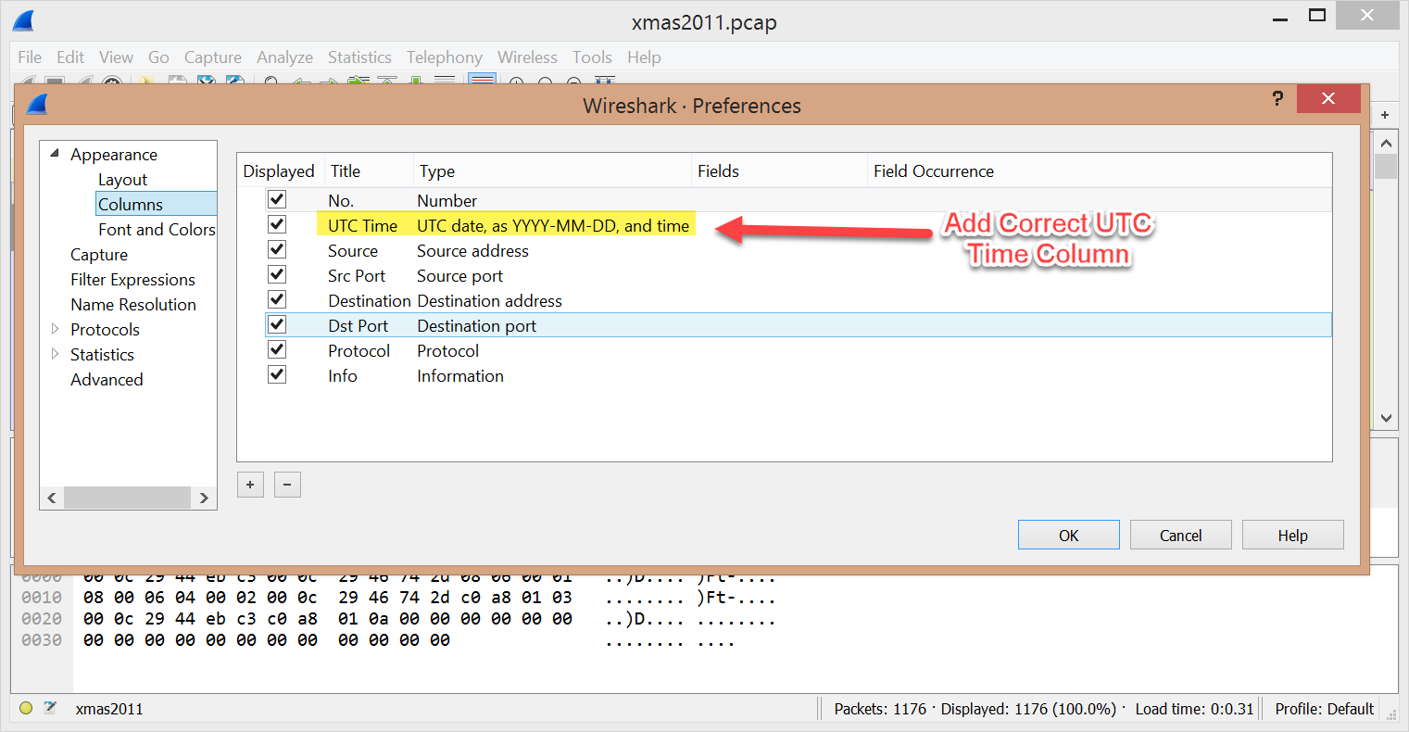

Figure . Adjust display columns in Wireshark. (Skoudis, 2011)

In the new layout, the time column displays milliseconds which should be removed (Figure 38).

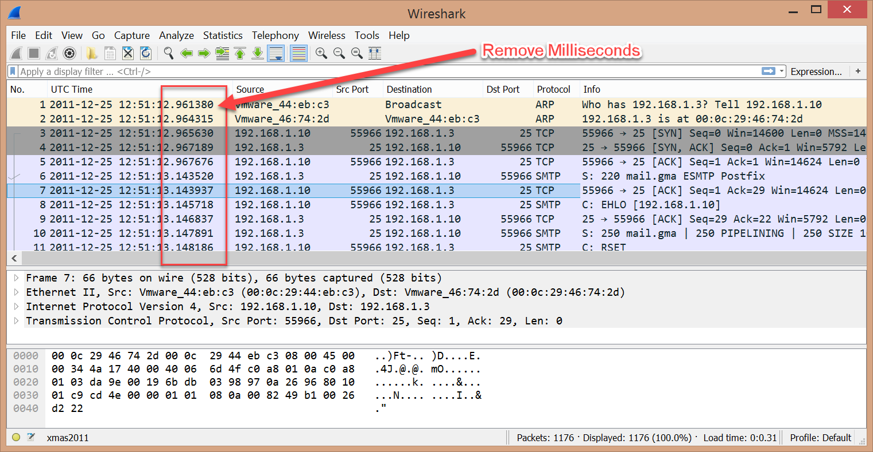

Figure . Remove milliseconds. (Skoudis, 2011)

To remove milliseconds, on the toolbar, click ‘View’, then ‘Time Display Format’, and finally ‘Seconds’ (Figure 39). This will remove the milliseconds from the column and display the time only to the second (Figure 40).

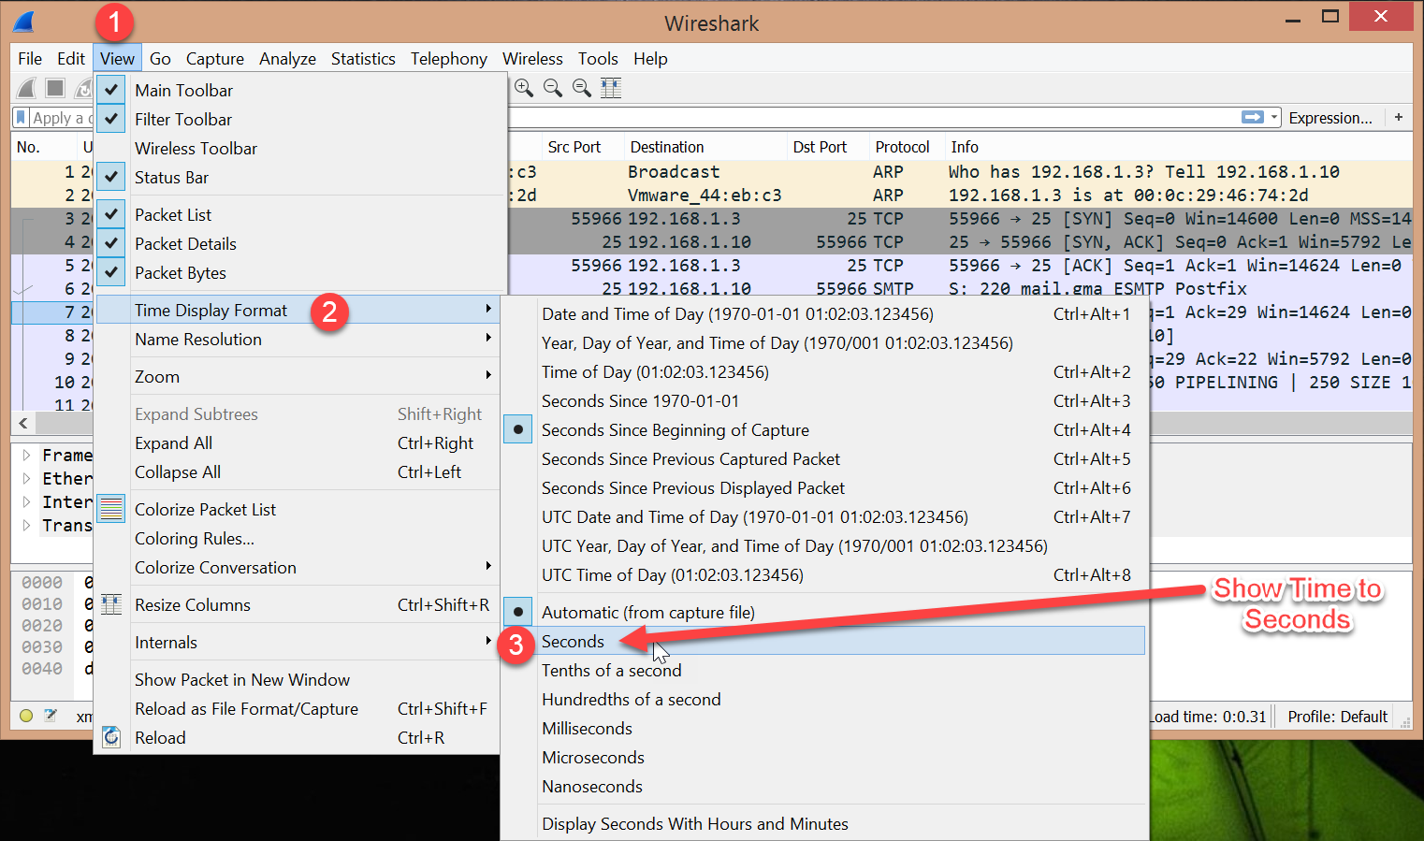

Figure . Time Display Format. (Skoudis, 2011)

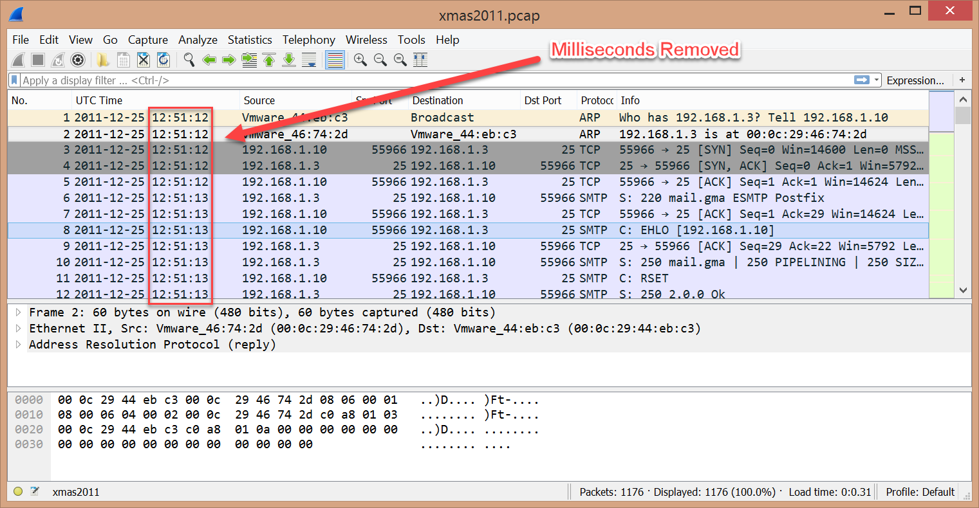

Figure . Milliseconds removed. (Skoudis, 2011)

Wireshark is now configured to export the data in an Excel-friendly format. Click on ‘File’, then ‘Export Packet Dissections’, and then ‘As CSV…’. (Figure 41)

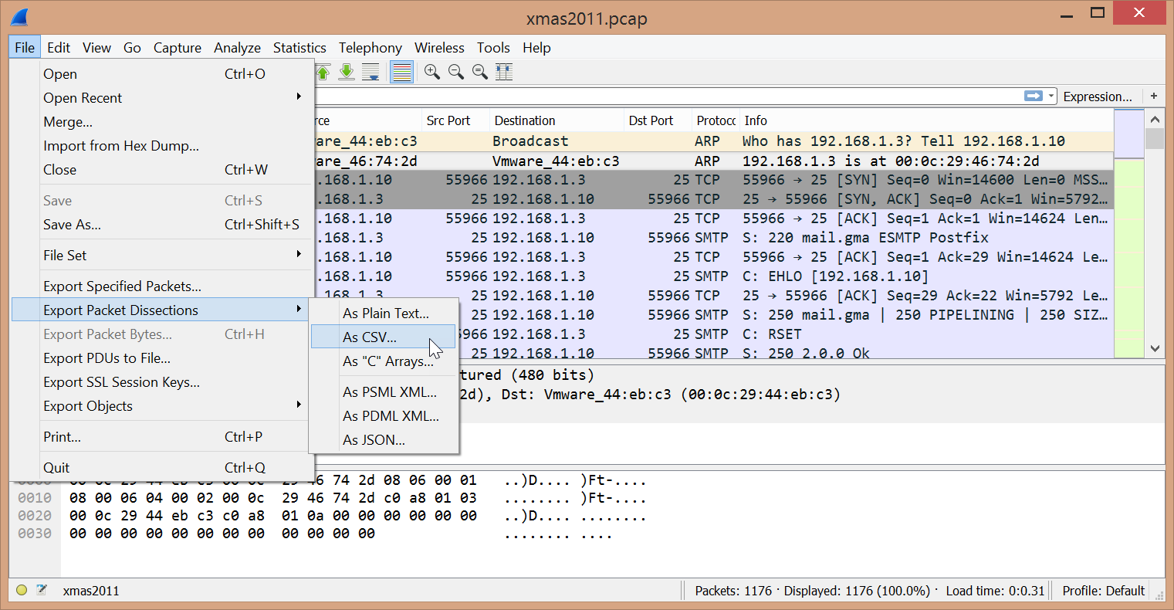

Figure . Export packets. (Skoudis, 2011)

In the ‘Export File’ pop-up window, make sure that CSV is chosen in the ‘Save as type’ drop down box and that the file name includes the .CSV extension (Figure 42).

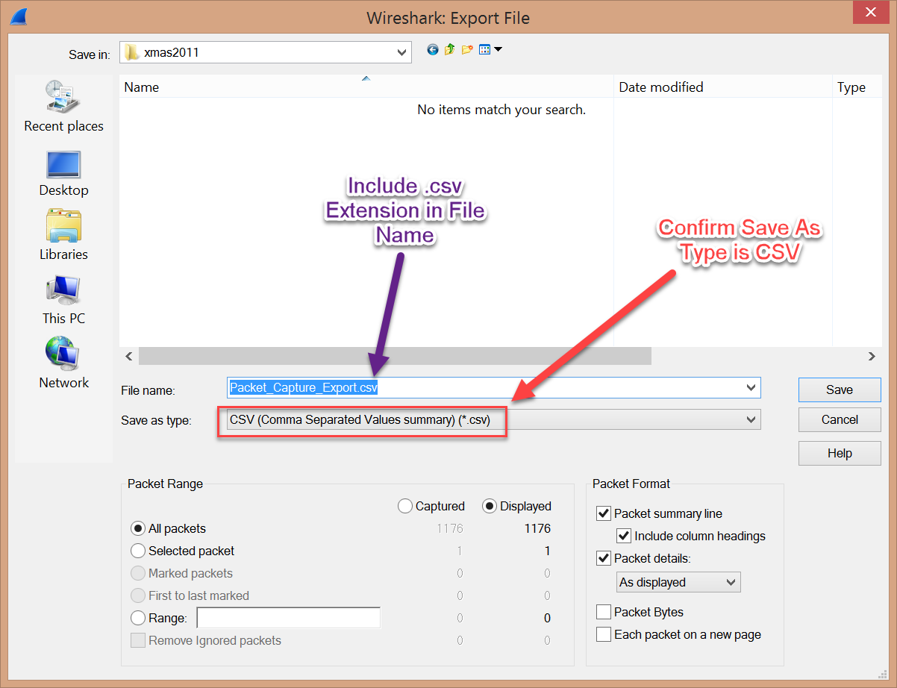

Figure . Export as CSV file. (Skoudis, 2011)

Open the resulting .CSV file in Excel. Several columns need to be combined to fit into the final formatting template of this document (Figure 43).

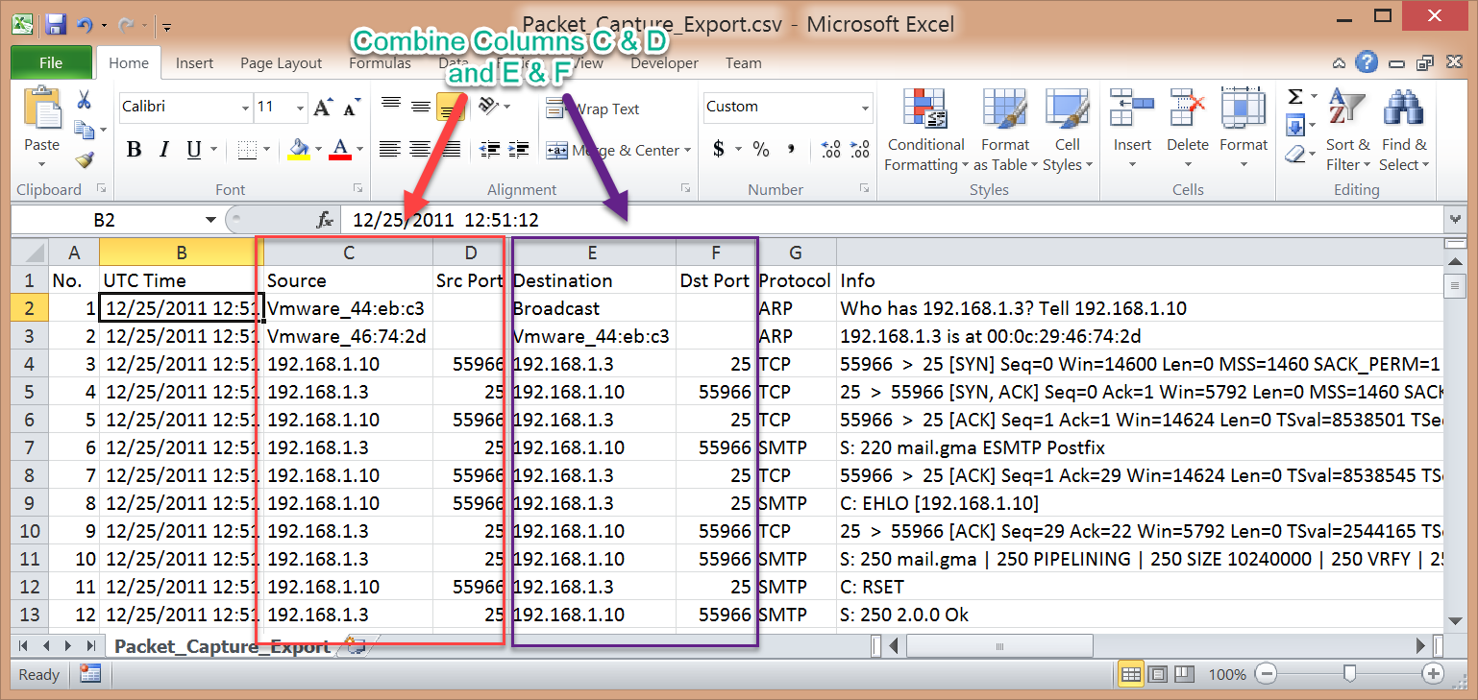

Figure . Combine columns. (Skoudis, 2011)

As described early, use a function to concatenate the two columns into one, along with descriptive strings to identify the data (Figure 44).

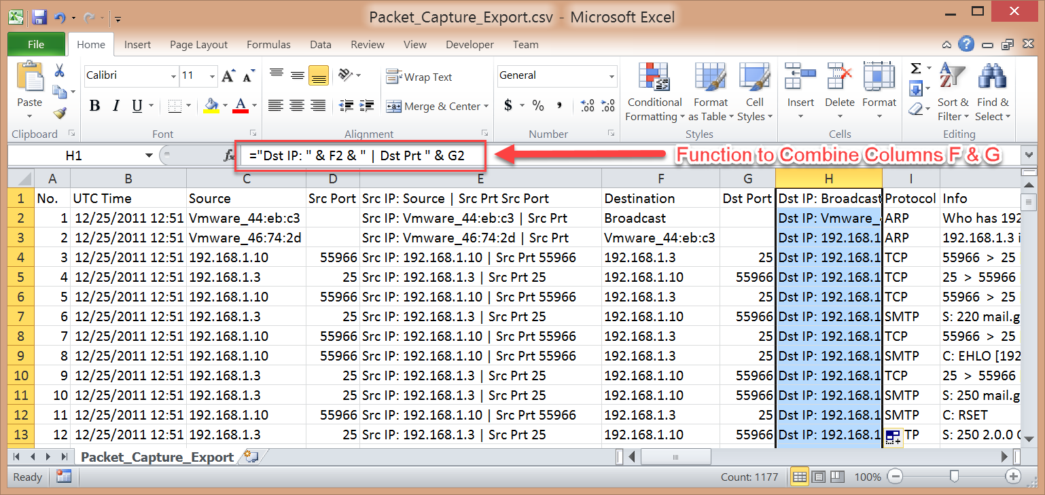

Figure . Descriptive strings added to values. (Skoudis, 2011)

One thing to note when manipulating the data is that the order of packets may be relevant to the investigation. Since the milliseconds have been removed from the time column, multiple packets will show as having the same time (Figure 45). This could alter the order of packets when sorting the data. To keep the packets in chronological order, the Number (No.) column is kept until the data is in its final state, at which point, the column is removed (Figure 46).

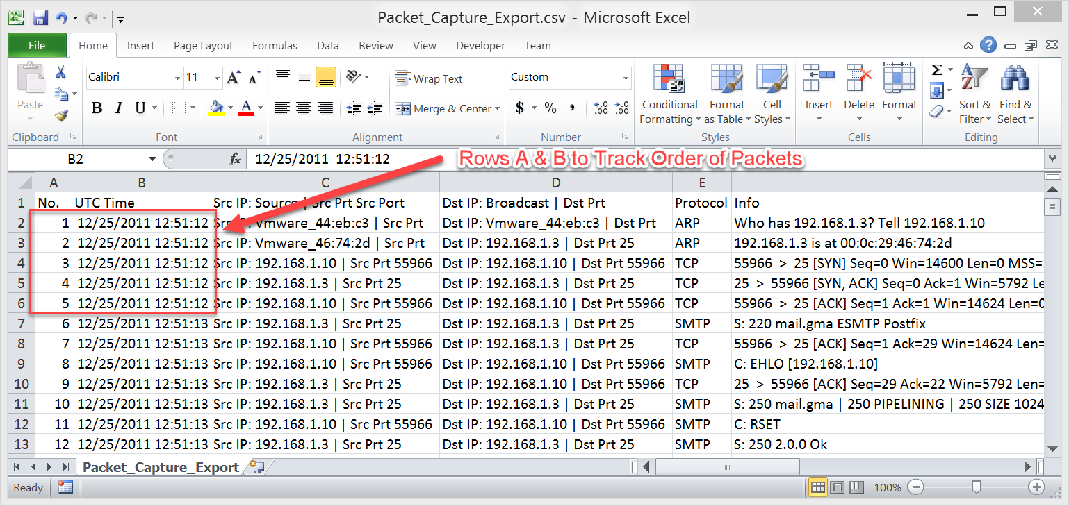

Figure . Number column kept for packet order. (Skoudis, 2011)

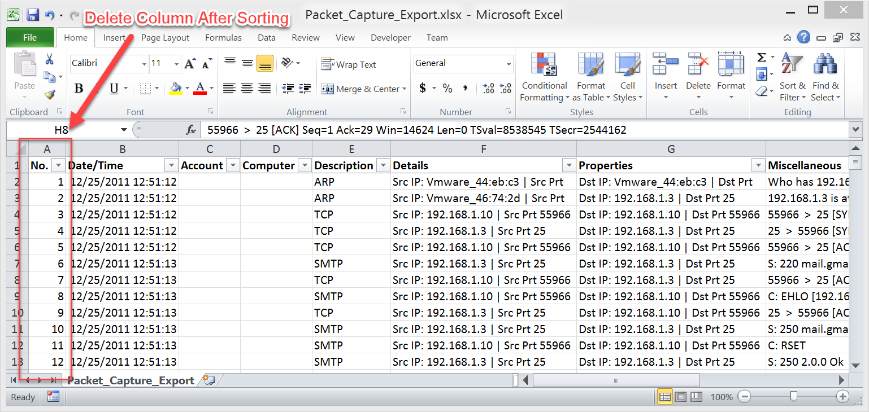

Figure . Delete number column after sorting. (Skoudis, 2011)

The final output should look like Figure 47.

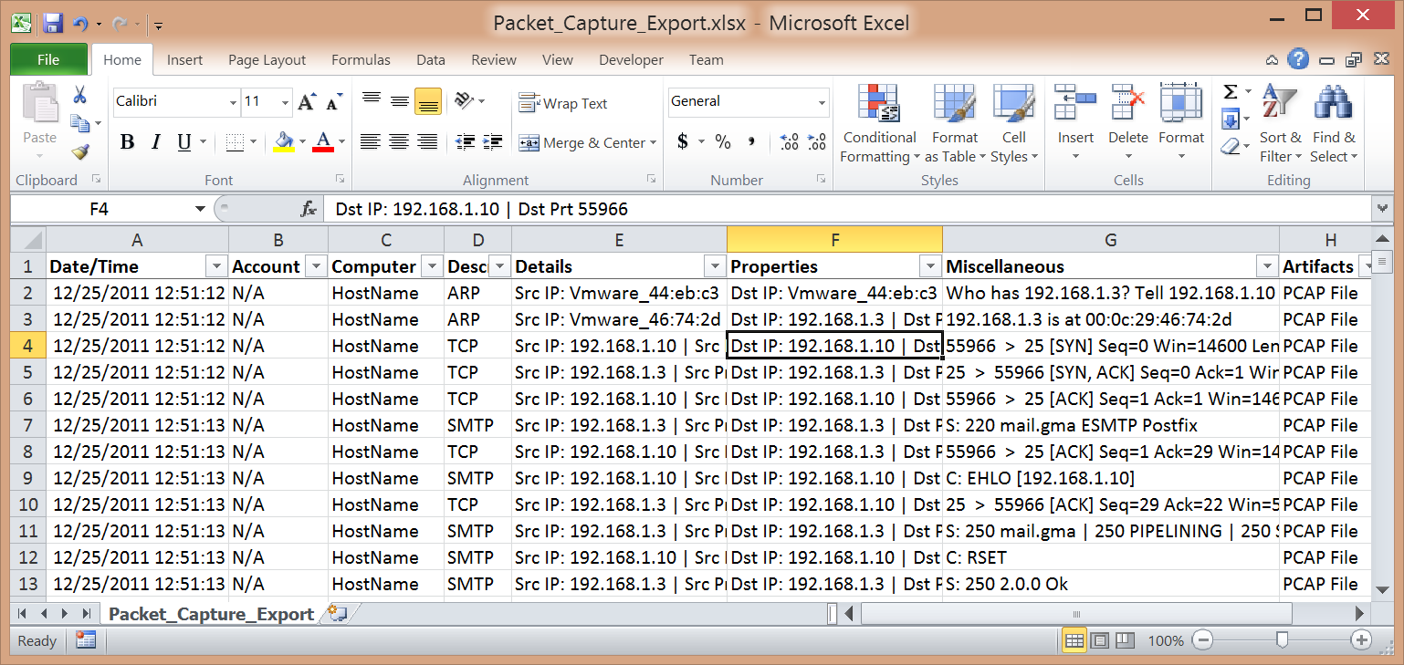

Figure . Final result. (Skoudis, 2011)

## IPS/IDS Logs

Host-based and network-based IDS logs are critical to incorporate into the analysis as it may be the primary reason you are aware of the intrusion in the first place. These logs usually contain data from the best vantage point, either from the network or host perspective.

### Snort

Snort is an open source product that “supports sending real-time alerts when an intrusion event is detected and can even be used as an inline ‘intrusion prevention system’ that enables you to receive alerts in real time and in several different medium, rather than having to continuously sit at a desk monitoring your Snort system 24 hours a day” (Caswell, 2007, ch. 2).

This document will look at the logs produced by running snort in Fast alert mode which “writes the alert in a simple format with a timestamp, alert message, source and destination IPs/ports” (Roesch, 2003).

To get the logs in the standard format, the following SED command is used against the file to properly delineate the data:

*sed -E 's/-/\/2015 /; s/\[\*\*\]/#/g; s/\[[^][]*\]//; s/\[Classification:/#Classification:/g; s/\] \[Priority:/#Priority:/g; s/\] \{/#/g; s/\} /#Source: /g; s/ -> /#Destination: /g' alert.fast.log*

Import the resulting file into Excel using the “#” character as the delimiter. Move column D to the last column of data and delete columns F, E and C (Figure 48).

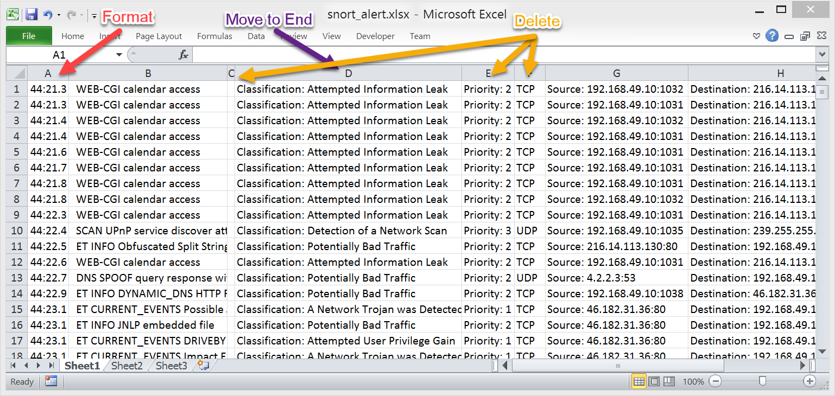

Figure . Move and delete columns. (Sconzo, "SecRepo.com")

Insert the standard columns and apply the standard formatting and headers (Figure 49).

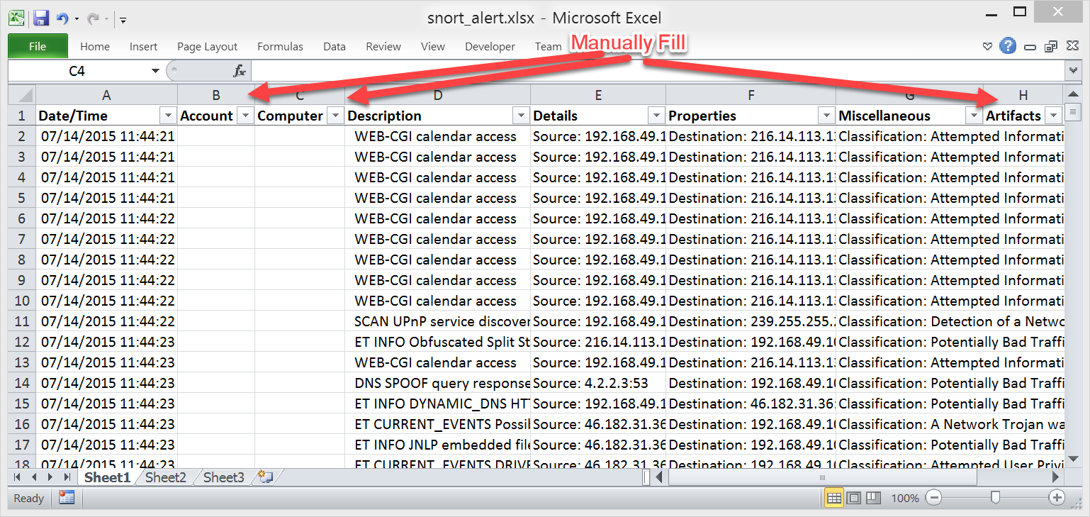

Figure . Standard headers and formatting applied. (Sconzo, "SecRepo.com")

The final result should look similar to Figure 50.

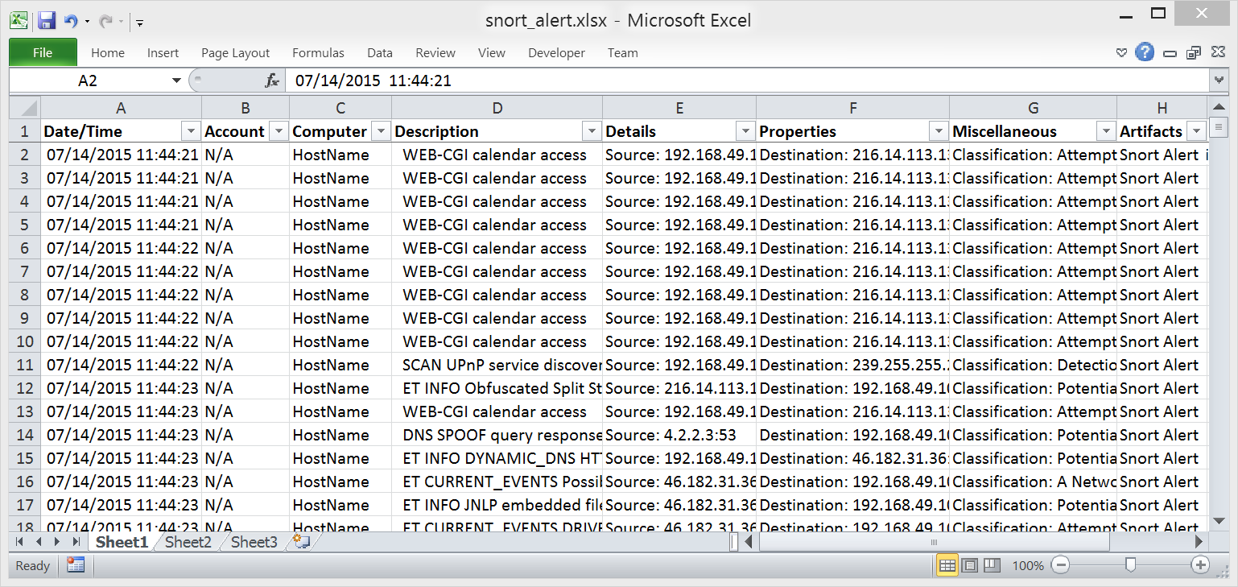

Figure . Final result. (Sconzo, "SecRepo.com")

### Bro

Bro is another open source intrusion detection system. “Bro inspects all traffic flowing into and out of a network. It can operate in passive mode, in which it generates alerts for suspicious activity, or in active mode, in which it injects traffic to disrupt malicious activity…Unlike other NIDSs, Bro monitors traffic flows rather than just matching patterns inside individual packets. This method of operation means that Bro can detect suspicious activity based on who talks to whom, even without matching any particular string or pattern” (Nemeth, 2010, ch. 22). Bro produces several logs, each of which can use the techniques described in this section to achieve our standard layout. Here are some of the logs Bro generates: Conn, DHCP, DNS, Files, HTTP, Weird, etc. The supplement will examine the Bro Connect log (conn.log) which records TCP, UDP and ICMP connections.

Import the log into Excel using ‘Tab’ as the delimiter. The log has several header rows (1 thru 6, & 8), which are removed (Figure 51).

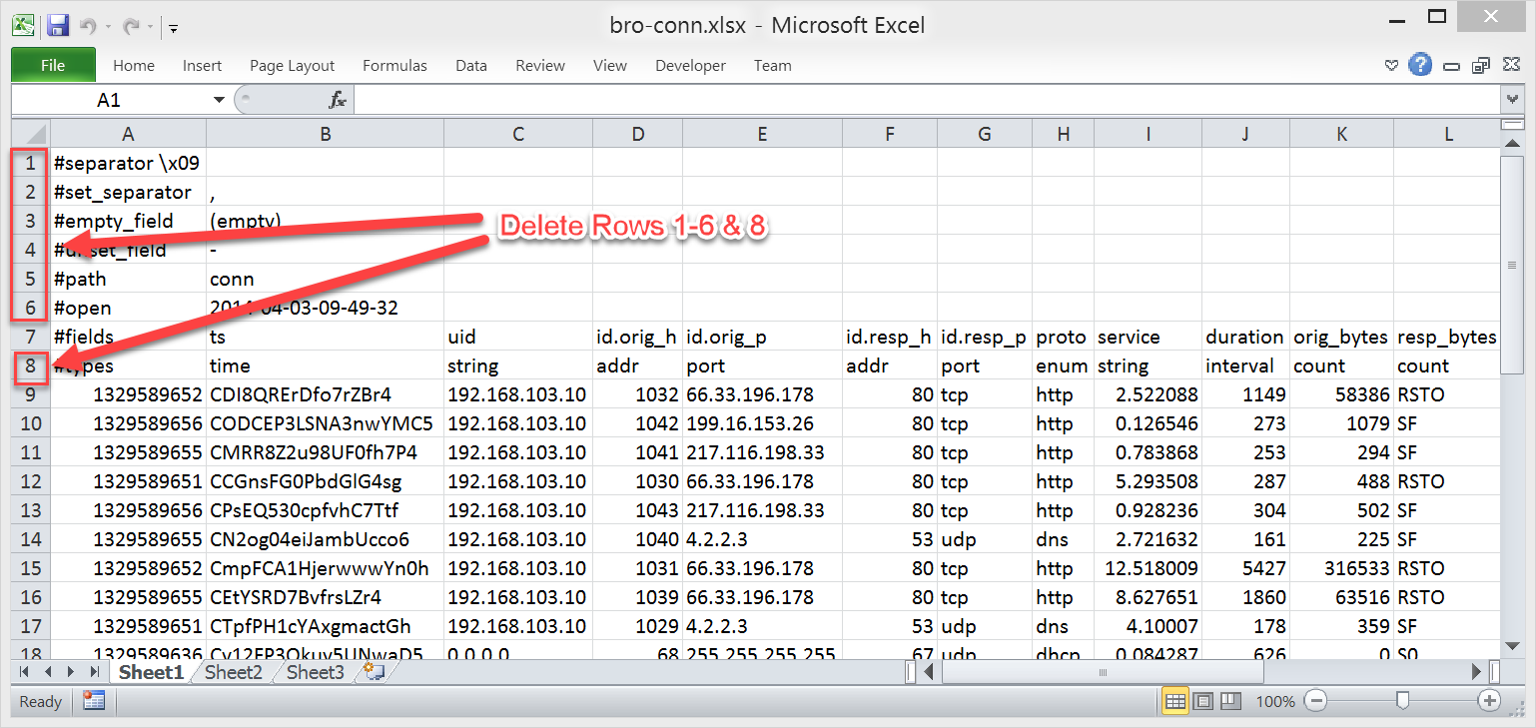

Figure . Delete Bro header rows. (Sconzo, "SecRepo.com")

Cell “A1” should now contain the string: ‘#Fields:’ which will be deleted. Shift the remaining header fields in the first row to the left to line up properly with the data in each column (Figure 52).

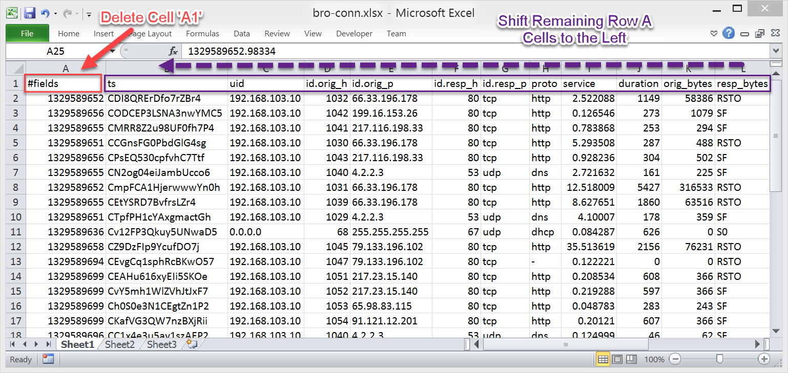

Figure . Shift remaining headers to the left. (Sconzo, "SecRepo.com")

Looking at the ‘ts’ column, the values in the cells are actually timestamps formatted in Epoch time. These values need to be converted to human readable time (Figure 53).

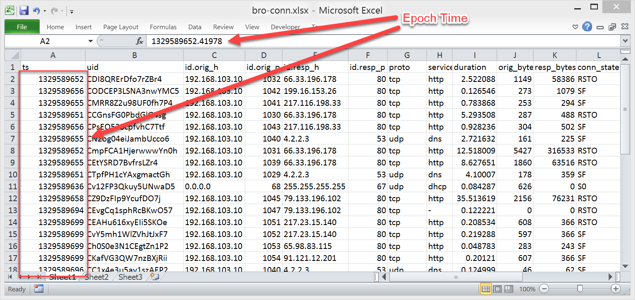

Figure . Epoch Time. (Sconzo, "SecRepo.com")

This conversion can be done with the following function (Figure 54):

*=A9/(60*60*24)+"1/1/1970"*

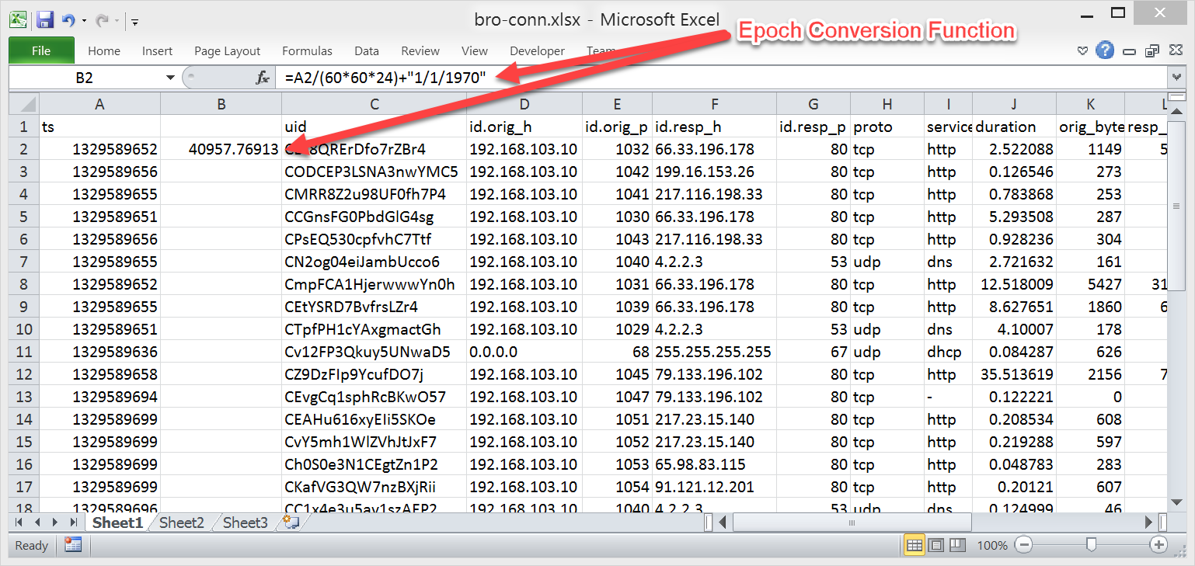

Figure . Convert Epoch Time. (Sconzo, "SecRepo.com")

Once the time has been fixed, various columns can be moved, combined and deleted (Figure 55).

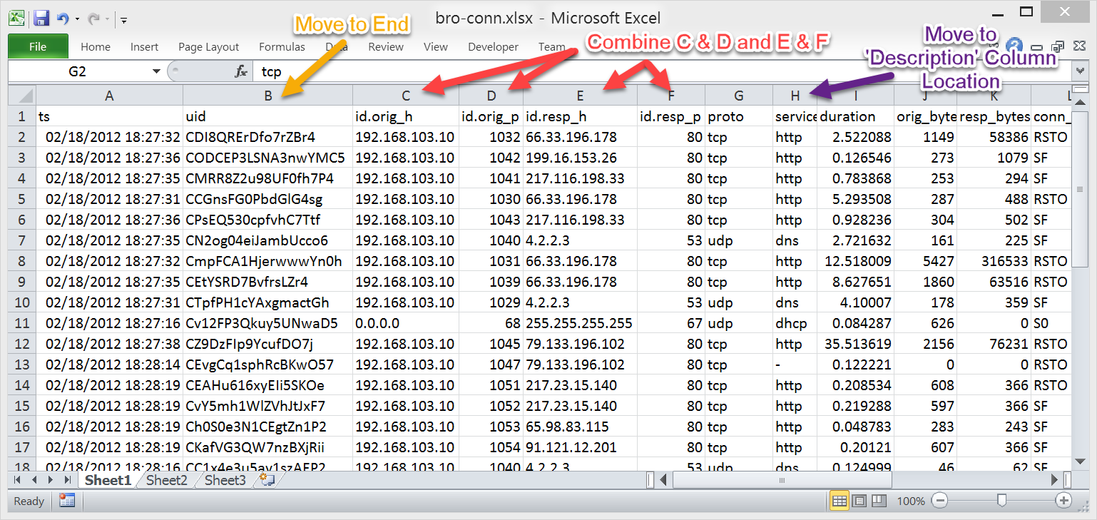

Figure . Manipulate columns. (Sconzo, "SecRepo.com")

Add missing standard columns and prefix the UID column for proper identification of the data (Figure 56).

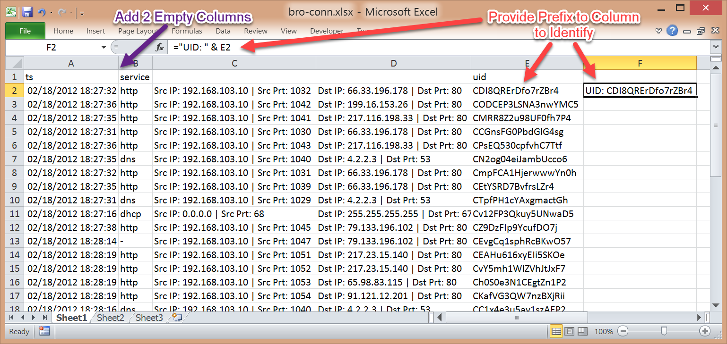

Figure . Add Standard Columns and prefix string to UID value. (Sconzo, "SecRepo.com")

Apply the rest of the standard columns, headers, formats and the result should look similar to Figure 57.

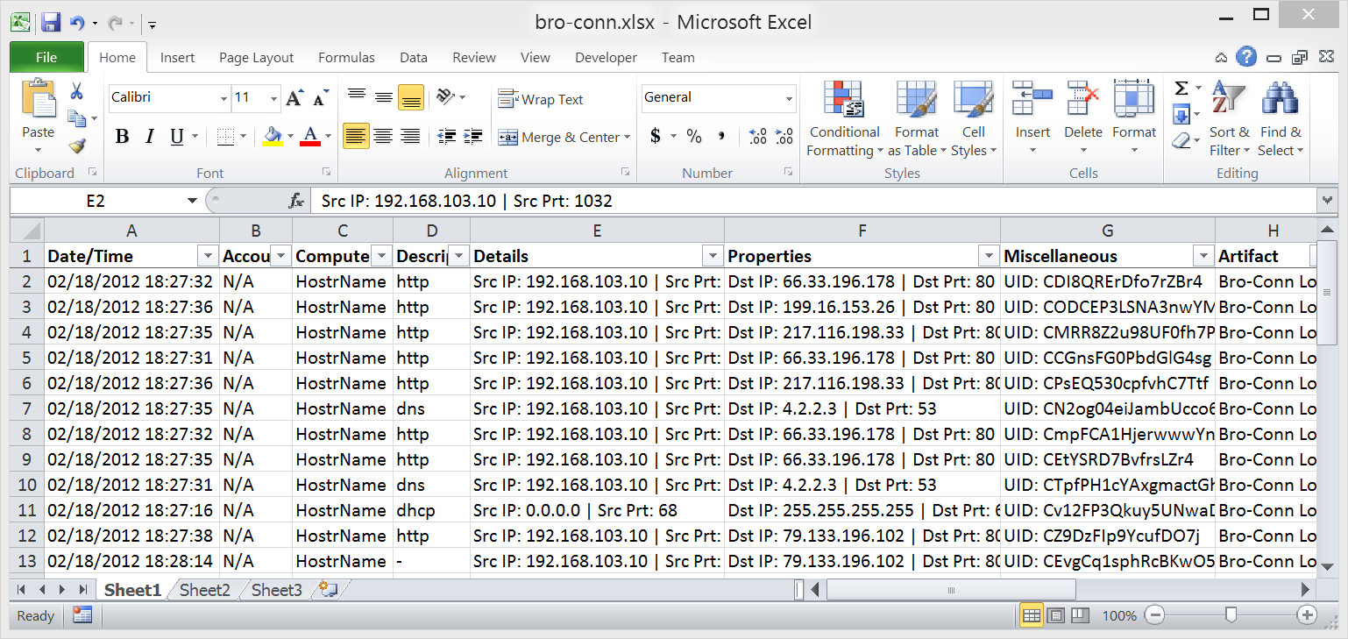

Figure . Final result. (Sconzo, "SecRepo.com")

References

Arcas, G., Gonzales, H., & Cheng, J. (2011). *Challenge 7 of the Forensic Challenge 2011 - Forensic Analysis of a Compromised Server | The Honeynet Project*. Retrieved from http://www.honeynet.org/challenges/2011_7_compromised_server

Caswell, B., Beale, J., & Baker, A. (2007). *Snort Intrusion Detection and Prevention Toolkit*. Syngress

Chuvakin, A. (2004, February 29). *Public security log sharing | SotM30-anton.log.gz*. Retrieved from http://log-sharing.dreamhosters.com/

Gerhards, R. (2004, March 29). Cron daemon log samples. Retrieved from http://www.monitorware.com/en/logsamples/cron.php

Jimmij. (2015, March 3). *How do I replace the last occurrence of a character in a string using sed?* Retrieved from http://unix.stackexchange.com/questions/187889/how-do-i-replace-the-last-occurrence-of-a-character-in-a-string-using-sed

John1024. (2014, September 16). *Sed -- Replace first k instances of a word in the file*. Retrieved from http://unix.stackexchange.com/questions/155805/sed-replace-first-k-instances-of-a-word-in-the-file

Lee, R. (2014). *SANS Forensic 508 Advanced Computer Forensic Analysis and Incident Response, Stark Research Labs Intrusion: Exercise Workbook*.

Marty, R., Chuvakin, A., & Tricaud, S. (2010). *Challenge 5 of the forensic challenge 2010 - log mysteries | The Honeynet Project*. Retrieved from https://honeynet.org/challenges/2010_5_log_mysteries

Nemeth, E., Snyder, G., Hein, T., & Whaley, B. (2010). *Unix and Linux System Administration Handbook, Fourth Edition*. Prentice Hill

Roesch, M. (2003). *Network intrusion detection system mode | NIDS mode output options*. Retrieved from http://manual-snort-org.s3-website-us-east-1.amazonaws.com/node6.html

Sconzo, M. (n.d.). *SecRepo.com - samples of security related data*. Retrieved from http://www.secrepo.com/

Skoudis, E. & Hessman, T. (2011). *Grandma got all hax0red by a reindeer... or did she?* Retrieved from https://pen-testing.sans.org/holiday-challenge/2011